Business Justification
for the development of new ISO 20022 financial repository items

- Name of the request:
Exceptions and Investigations Request/Response message definitions
- Submitting organisation(s):
ISO 20022 Payments SEG E&I Work Group
- Scope of the new development:
The Exceptions and Investigations work group proposes two new exceptions and investigations messages (request message and response message) to exchange between parties effectively handling of Payments Exception and Investigation.
These “proposed exception handling messages” are ultimately to replace the “existing set of exceptions handling messages” (camt.032, camt.033, camt.034, camt.035, camt.036, camt.037, camt.038, camt.039, camt.026, camt.027, camt.028, camt.087) as we consider the proposed messages would be future proof and create a basis for standardized workflows/processes to facilitate end-to-end automation/efficiency of global E&I cases management for the wider community.
These generic request and response messages intend to cover current and future use cases through usage of codes to differentiate the various types of investigations related to any current and future “clearing and settlement methods” available (i.e., correspondent banking, ACH such as SEPA, IP, cheques etc.).
It should be noted that, given their wide use, Cancellation message, for example the camt.055, camt.056 and the use of camt.029 to resolve these, are considered out of scope of this Business Justification and will continue to support the industry.
The E&I WG proposes that the Payments SEG is assigned to the evaluation of the candidate messages.
The Business Application Header (BAH) will be used with the ISO 20022 candidate message definitions.
The E&I WG will deploy the new messages in ISO 20022 XML syntax. Any other syntax has not been considered for now.
- Purpose of the new development:

Overall market context elements considered by the ISO 20022 Payments SEG E&I Work Group
- Exception handling has always been a pain point for the overall payments industry as these processes result in direct impacts for the end customers which are confronted to (sometimes extended) delays in payment processing when an investigation is needed. This impact is mainly due to a lack of standardisation in the tools and processes currently being used in the market.
- The current ISO Exception and Investigation message collection were developed many years ago where the process was largely manual but were never implemented due to their underlying complexity. Over the years the payment business and technology has evolved requiring new exception and investigation business scenarios / opening new opportunities (such as increased sanctions and Financial Crime request for information).
- Today, the current set of ISO messages for E&I are hardly used in the market (with a notable exception of camt.055/056/029 that is part of most system evolutions towards ISO payment formats and is considered out of scope of this exercise). The reason for lack of adoption is large because of the number of messages within the Exceptions and Investigations collection of messages, but also because of the message model complexity. Various actors today rely mainly on legacy formats such as the MT19X/29X formats to perform investigations.
How are Exceptions handled today (MT based)
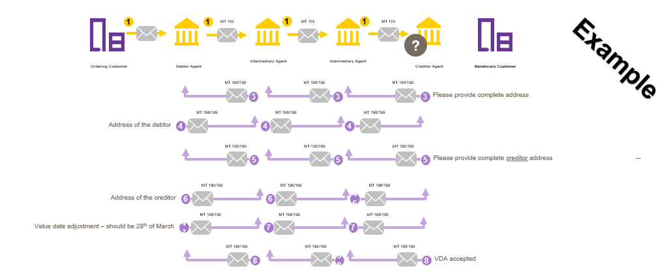
Main objectives of the ISO 20022 Payments SEG E&I Work Group
Given above contextual elements, the Work Group has focused on the following objectives:
- Simple solution for implementation and maintenance - the complex structure of the current messages prevents easy adoption of any new business scenarios whereby a newly designed set of request and response message is considered more fit for purpose, enabling an increased agility to adapt to an evolving business need.
- Efficient solution through increased standardisation - for all exception handling, promoting usage of structured requests with enhanced routing options to increase efficiency in the E&I processes overall and that supports automation capabilities for all parties in the exception chain. As a result of this, we shall also directly reduce complexity for manual operations
- E&I capabilities aligned with existing and future capabilities – the proposed solution must serve the industry in the migration to ISO 20022, be technologically agnostic and facilitate support of any new payment instruments / new use cases with minimal cost & time
The Work Group has addressed a series of pain points as raised by the members to identify root cause and potential structural solutions to solve these such as
- Case priority levels – how to address different levels of criticality of requests
- Need to propose efficient handling for multi-use cases / multi-question requests
- Meaningful codes and clear definitions of usage guidelines to avoid ambiguity on queries & responses
- Lifecycle of requests and chasing mechanisms
- Domain/Nature of the request & related routing questions
- Ambition to reach minimal usage of free text format/ad hoc channels for transactional enquiries

After a generic approach of the current pain points, and in-depth discussions on possible solutions to address these, the work group reviewed the existing Exception and investigation collection, considering whether adaptation of the existing collection achieved the business need or contemplated whether the constraint of the existing message collection justified the development of new messages.
The work group review concluded that it was important to create a simple request and response message where business scenarios/ investigation types can be adopted as attributes or external codes. It not only simplifies the implementation, but it also gives flexibility and agility towards adopting new business scenario. Next the above, modification of the current set was considered too cumbersome, while not reaching the ultimate objective.
Furthermore, the currently limited adoption (and usage) of the existing set of ISO 20022 E&I messages (with the exception of the Request for Cancellation messages), combined with the global move to ISO 20022 standards in the payments industry provides a unique opportunity to aid the painful exception handling and improve the client experience. The proposed messages are scheduled to be implemented across the entire correspondent banking community, without disrupting the user communities of the current ISO 20022 E&I set of messages. The new E&I messages should be considered the new generation of messages replacing the existing set over time and become the basis for evolution in case of needs identified by the global community.

Example – New process needed for new usage (ie CBDC)
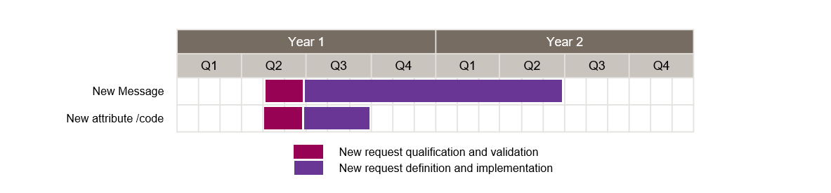

- Community of users and benefits:
The impacts of exception handling are commonly estimated of having at least annually 2 billion EURO impact overall for the wider payment industry- this figure being conservative as based on international payments only. This overall cost for the industry covers a wide variety of elements such as professional usage of these exception handling messages, as well as all the systems built at community and individual institution level to manage these exception handling processes.
Next to its overall cost, the end-user perception is to be considered, as exception handling processes have a high impact on processing time of payments. These extended delays are not compatible with the overall evolutions payments towards instant processing.

Implementation of these proposed query and response messages for Exception handling will have a material impact on
- Reduced implementation cost for the market (banks as well as vendors) through implementation of limited set of messages instead of extended existing set of messages
- Reduced maintenance cost for banks and vendors on the long term given the embedded flexibility of these proposed messages to accommodate new use cases
- Increased efficiency of professional users with clear request messages and guidelines to avoid useless processes and incomprehension
- Enable automation of most frequent queries with native structure of the proposed messages
- Enhanced routing of queries throughout various message users that are potentially spread in different teams (payment processing, Sanctions screening etc)
All above elements, even though not measurable given the incumbent complexity, will considerately reduce the cost of exception handling throughout the wider community and increase the end-client value perception.

Adoption scenario
To facilitate the industry demand and make use of the global ISO migration projects, the new messages would require to be published by ISO in 2023 for wider community adoption in 2024.
With regards to the current message set, we propose the following approach
- No further maintenance on the current message set as from approval of this request
- Once the new messages are widely adopted (expected by end of 2025), evaluate the rather limited use of the current messages and consider a potential end-date or removal from ISO 20022 message catalogue (with the exception of camt056/029 – see below)
- Considering the implementation of the camt.055, camt.056 and camt.029 (in response to the camt.055 and camt.056) are out of scope of this Business Justification.
- Implementation of proposed set of messages across all institutions / actors will be aligned with current global migration strategies (end date of legacy SWIFT MT messages for Category 1,2 &9 by Nov 2025)

The propositions (proposed messages, implementation strategy, timelines etc) are supported by
- Swift community – for all international payments in scope with the expectation to be used for x-border and domestic E&I handling
- All participants in the ISO 20022 Payments SEG Work Group

- Timing and development:
The justification will describe:
The ISO 20022 adoption across the global industry is increasing fast. However, due to the lack of a better alternative the legacy free-format MT messages are still used for exceptions and investigations leading to manual handling and delays in payment execution.
The Work Group proposed to develop the new set of messages with priority by 2023, for deployment in 2024 allowing sufficient time for the users and vendors for development, testing and adoption.

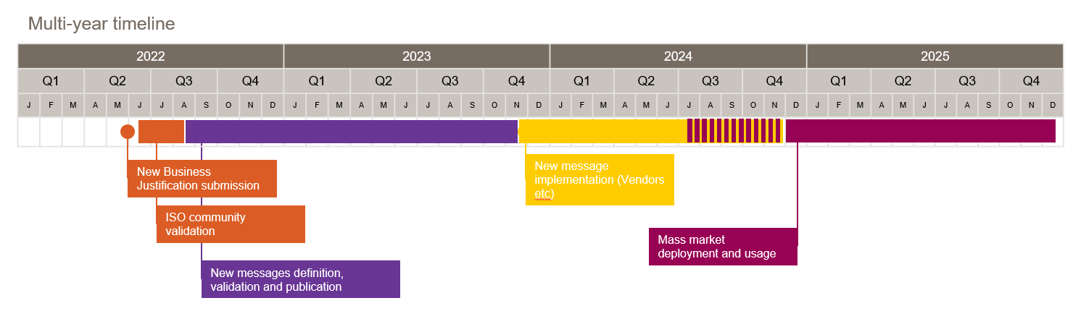
- Contact persons:
- Charlie Clarke - cclarke@cdnpay.ca –
- Neil Buchan / Maxime Wouters – SWIFT - neil.buchan@swift.com; maxime.wouters@swift.com

- Comments from the RMG members and relevant SEG(s) or SubSEG(s) and disposition of comments by the submitting organisation:
This section will include the comments received from RMG members and the SEG(s) or SubSEG(s), if any, and the response given to each of these comments by the submitting organisation.
CSH: the CSH confirms that this business justification is in the scope of the Payments SEG.

EPC:
In SEPA, the camt.027 and camt.087 messages are used since 2019 in the context of SEPA Credit Transfer (SCT) inquiries. Moreover, it is to be noted that the usage of these messages is increasing (as reported by different communities).
- Could further clarification be provided on whether the camt.029 message is in or out of scope of this business justification?
  - In section C it is noted that “given their wide use, Cancellation message, for example the camt.055, camt.056 and the use of camt.029 to resolve these, are considered out of scope of this Business Justification and will continue to support the industry” and in section E it is stated “Considering the implementation of the camt.055, camt.056 and camt.029 (in response to the camt.055 and camt.056) are out of scope of this Business Justification”.
  - From the above we understand that the camt.029 is clearly out of scope when it is used as a response to a camt.055 and camt.056. However, in SEPA the camt.029 is for example also used as a response to a camt.027 and camt.087.
  - Would the camt.029 message itself need to be modified in case the camt.027 and camt.087 would be replaced by new E&I messages? (as in the current camt.029 there is e.g. a block “Claim Non-Receipt Details”).
Response to EPC
Clarifications on timeline and usage
- EPC indicates that decision was taken to use 2019 versions of existing set of messages from November 2023 (full documentation and corresponding XSDs already published) and hence the need to avoid imposing multiple migrations within their community in a short period
- NBJ initiators have confirmed that usage of selected version (i.e., camt.027.001.07 and cam.087.001.06) can continue within SEPA community for as long as needed. Moreover, these versions can be used alongside deployment of new message set on international payments without any hinder
- Indication in the NBJ to discuss later “removal from ISO message Catalogue “ of the existing set doesn’t impact continued usage of existing set, but has been proposed to avoid misunderstanding within the community by having multiple messages covering the same business area
- EPC could consider implementing new set at their best convenience and at timings defined by their community

Clarifications on Request for cancellation
- NBJ initiators confirm Camt 055, Camt 056 and Camt 029 (as a response to request for cancellation) are not in scope of this NBJ.
- This position was defined within the group given these messages are considered as fit for purpose and being widely adopted”
- Nevertheless, if the BJ is accepted and in order to avoid any future ambiguity between camt.029 and the new answer message, the current camt.029 should be seriously reduced in order to only answer camt.055/056.

SOCGEN
Regarding "Correspondent Banking" activity, this BJ is definitively – for me – a good thing but my fear, even the EPC has been consulted, is to be obliged to change the current SEPA messages (camt.032, camt.035, camt.036, camt.037, camt.038, camt.039, camt.026, camt.027, camt.028 and camt.087) to implement these new 2 E&I messages… and the appropriate new codes! In addition, and for instance, I don't understand why the camt.033 (RequestForDuplicate) and the camt.034 (Duplicate) are not included.

On page 4, it is mentioned "These extended delays are not compatible with the overall evolutions payments towards instant processing" but as soon as you have an E&I, the Instant Payment is no more possible: did I miss something?

Response to SocGen
- Cfr answer to EPC
  - SEPA can continue using “existing” set of messages as long as they want, there shall be no obligation whatsoever to evolve to the proposed messages
  - The whole consideration on “removing existing set from the catalogue” is
    - Just one of multiple propositions to avoid misunderstandings
    - Does NOT impact the fact that any organization can continue using the messages applicable in their community
  - EPC confirmed it’s not their intend to switch to the new formats in the coming years
- Section E, page #4 does not refer to instant payments, but to the long lifecycle of an investigations case and the lack of automation currently, which is totally contradicting the development/evolution of technology and the demand for real-time, digital services globally. Hope this clarifies.
- Wrt camt.033/034 – we have indeed missed to indicate these – see modification in section C above

Based on 35 million E&I messages exchanged on the Swift network, with a conservative estimate of ~50 to 100 euro/investigation

