Business Justification
for the development of new ISO 20022 API Resource
Note: the purpose of this document is to give guidelines to organisations that want to develop new candidate ISO 20022 resource definitions. Such requests are subject to the approval of a business justification by the ISO 20022 Registration Management Group (RMG). Please consult the iso20022.org website for additional details on the registration process. The business justification must include the following captions, as described. Business justifications are to be uploaded at www.iso200222.org

- Name of the request:
Collateral and Exposure, Margin Call and Collateral Status API resource

- Submitting organisation(s):
LCH Group
SWIFT SCRL

- Scope of the new development:
The proposed API resource encompasses collateral and exposure data that provides information about exposures, collateral balances and collateral movements as well as margin calls and status information on collateral proposals and substitutions.
The ISO 20022 business area is collateral management.
Based on today’s feedback, following are the refined use cases in priority order:

- Collateral and Exposure valuation (exposures, balances, movements, excess/shortfall)
- Margin Call breakdown (initial margin/variation margin and associated settlement amounts)
- Collateral Status (status enquiry on submitted instructions such as collateral proposals or collateral substitutions)

There is currently one resource in development
- Collateral and Exposure
And we expect resources for Margin Call status and Collateral status as well, though these are not yet thoroughly analysed.
Detailed business cases: Clearing Members require the ability to enquire on current levels an account’s net excess or deficit with respect to exposures and collateral. In order to assess if they need to take action on either existing instructions (such as a collateral proposal not settling) or to create a new instruction (such as to withdraw excess collateral)
  - Total collateral and exposure per account, plus net excess and deficit details
  - Provide a breakdown of existing collateral balances and exposures
  - Show open movements in these underlying assets
  - Value both the balances and movements (pre and post haircut)

Business collateral management flow illustrating the different exchanges of information. Business flows highlighted in orange are the ones that will be covered by the new API resource which would complement existing Colr.016 Collateral and Exposure Report:
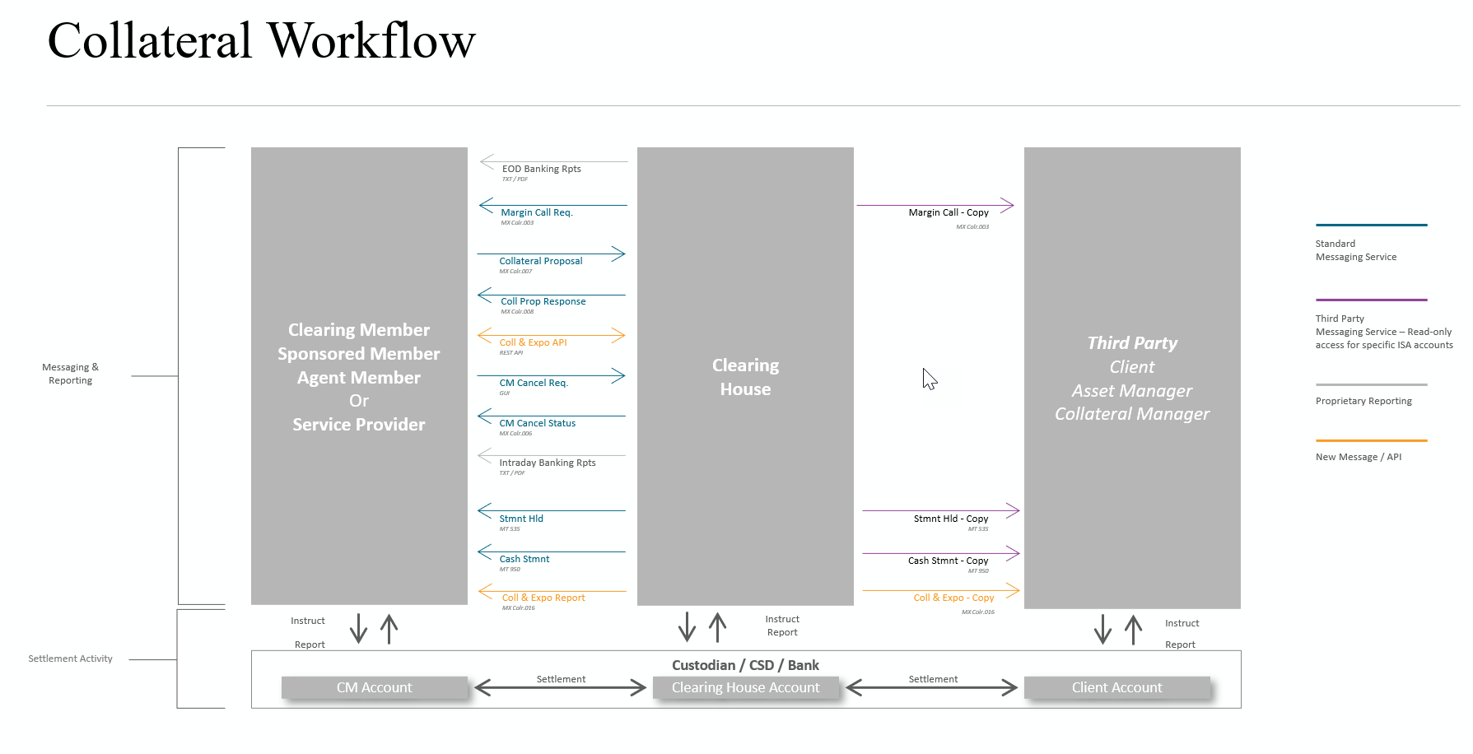

Specific business processes that will be covered by the new API resource are highlighted in blue:
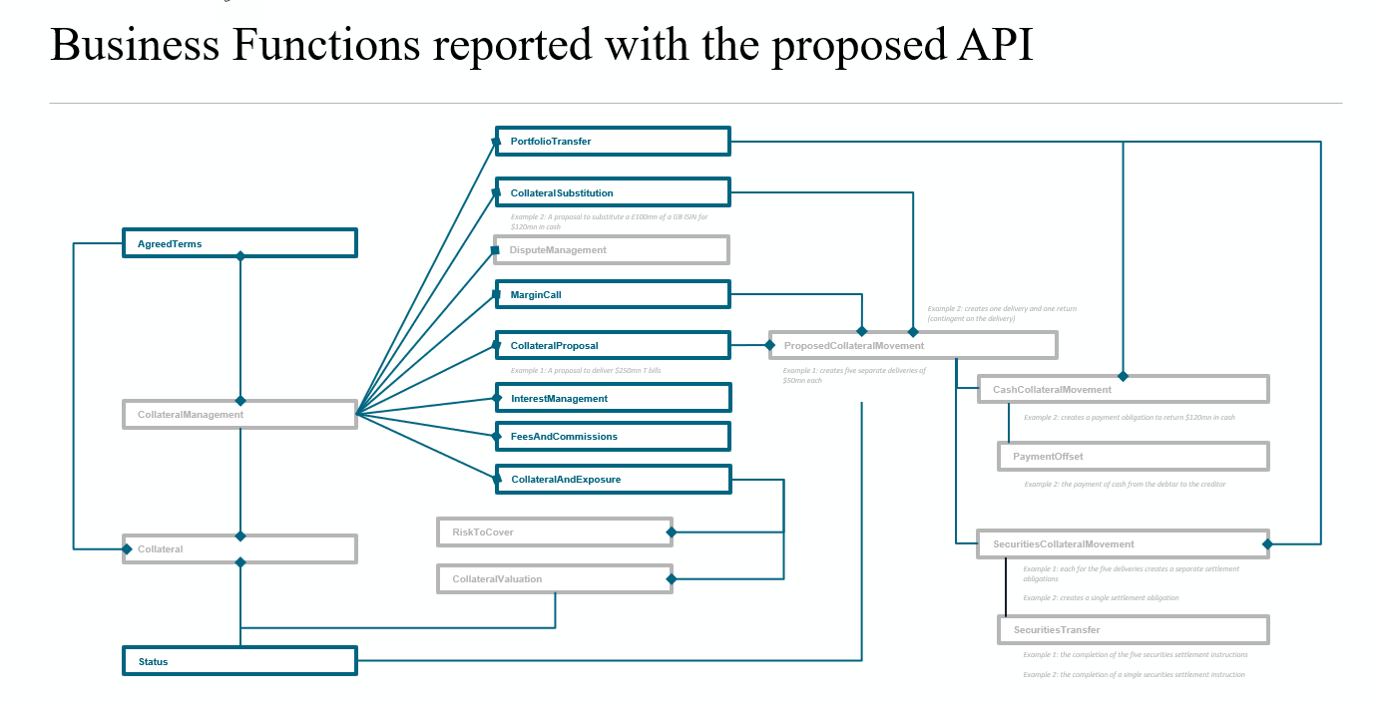

- Purpose of the new development:

The goal is to enhance collateral management services via ISO 20022-aligned APIs to complement the existing ISO 20022 messaging.

This development aims at a more integrated customer portal into the current back-office systems/setups, providing enhanced margin and collateral optimisation capabilities to their members, their clients and their vendors.
The API resource will make up for the following existing pain points:
- The missing collateral data – information that is not published in traditional proprietary reporting or web applications
- timeliness of data – where information is not available intraday, at the time you need it, or otherwise stale or out-of-date
- data formats – where information may only be accessible in a format that is complex for your systems to consume (i.e., an html web page or pdf report)
- standardisation – where data is currently presented in a non-standard way by the Cleating House, making processing difficult/expensive versus other providers

The data should be accessible equally to end users (i.e., GUI and html/pdf reports) and through automated system to system connections (i.e., xml message/reports and RESTful APIs).

First API use case will be a Collateral and Exposure call complementing existing Collateral and Exposure Colr.016 and Colr.022 messaging.
These API’s will be based on ISO20022 business components leveraging previous work in the construction of the colr messages – specifically the colr.16 message. In fact, most of the components used are already in the ISO repository.

Additional APIs use cases covering margin calls and collateral status will leverage existing business components from the colr.003, colr.006, colr.011, colr.012 and secl.005.

The query and response style of these communications make them eminently suitable for API development rather than ISO 20022 message development. So that end consumers can enquire on parts of the overall picture intraday via the API in between getting a complete statement via ISO 20022 message.
In addition, attention will be spent to make this resource comply with requirements of other players in the collateral management area. Therefore, the round of engagement should be broadened to other clearing houses next to the submitter and clearing members to make sure the APIs resources meet global industry requirements.

- Community of users and benefits:

The community of users will be:

- Clearing Houses
- Clearing members
- OTC service providers / aggregator platform partners

The benefits through the improvement in the current collateral service offering:

- more integrated, scalable, and modern customer portal across providing enhanced margin and collateral optimisation capabilities to clearing members and clients (and their vendors)
- the data should be accessible equally to end users (i.e., GUI and html/pdf reports) and through automated system to system connections (i.e., xml message/reports and RESTful APIs)

- Requested additional deliverables from the Registration Authority

N/A

- Commitments of the submitting organisation:
The submitting organisation must confirms that it can and will:
- undertake the development of the candidate ISO 20022 Resource(s) that it will submit to the RA for compliance review, registration and publication. The submission must be compliant with the ISO 20022 Master Rules. Once approved by the RA, the new resource(s) will be registered in the ISO 20022 Repository and published by the RA together with the RDR (generated by the RA).
- undertake the development of a web service API solution based on ISO 20022 Resources and using the ISO 20022 API modelling guidelines; the RA will not review, register or publish the API calls, but provides a page on iso20022.org where ISO 20022 API solutions can be referred to.
- address any queries related to the description of the Resource as published by the RA on the ISO 20022 website.
The submitting organisation confirms its knowledge and acceptance of the ISO 20022 Intellectual Property Rights policy for contributing organisations, as follows.
“Organizations that contribute information to be incorporated into the ISO 20022 Repository shall keep any Intellectual Property Rights (IPR) they have on this information. A contributing organization warrants that it has sufficient rights on the contributed information to have it published in the ISO 20022 Repository through the ISO 20022 Registration Authority in accordance with the rules set in ISO 20022. To ascertain a widespread, public, and uniform use of the ISO 20022 Repository information, the contributing organization grants third parties a non-exclusive, royalty-free license to use the published information”.

- Comments from the RMG members and relevant SEG(s) or SubSEG(s) and disposition of comments by the submitting organisation:
This section will include the comments received from RMG members and the SEG(s) or SubSEG(s), if any, and the response given to each of these comments by the submitting organisation.

Deadline for first comments: …...

Comments from Financial Institution A:

Comments from Financial Institution B:

- Contact persons:
Ben Doughton – Ben.Doughton@lseg.com
Tapas Bhattacharya – tapas.bhattacharya@swift.com
Karine Taquet – karine.taquet@swift.com
Tom Alaerts – tom.alaerts@swift.com

