Business Justification
for the development of new ISO 20022 API resources as ISO 20022 financial repository items)
Note: the purpose of this document is to give guidelines to organisations that want to develop new candidate ISO 20022 API resource definitions. Such requests are subject to the approval of a business justification by the ISO 20022 Registration Management Group (RMG). Please consult the iso20022.org website for additional details on the registration process. The business justification must include the following captions, as described. Business justifications are to be sent via e-mail to iso20022ra@iso20022.org

- Name of the request:
“Central Payment Tracking and Investigation Management Resources”
- Submitting organisation(s):
Swift, Avenue Adèle 1, 1310 La Hulpe, Belgium
- Scope of the new development:
The scope encompasses:
1/The tracking (via a central system) of customer credit transfers as well as of financial institution credit transfers:
- Domestic and international / cross-border (including currency conversion)
- Customer and Financial Institution credit transfers
- Serial and cover methods
- Rejects and returns
Note: we consider extending to direct debit if this in the future is requested by the community.
In terms of existing ISO 20022 business areas, the scope encompasses:
- pacs (payment clearing and settlement)
- pain (payment initiation)
- trck (tracking) /not yet registered but Business Justification approved.
2/The management and orchestration of payment cancellation and investigation (i.e. Exceptions & Investigations) requests and responses via a central system in relation to customer credit transfers as well as of financial institution credit transfers.
In terms of existing ISO 20022 business areas, the scope encompasses:
- camt (cash management)
- pacs (payment clearing and settlement in context of E&I)

Actors interacting via APIs with the central system would include:
- Financial Institution (FI)
- Payment Market Infrastructures (PMIs)
- Payment Service Providers (PSPs)
- NBFI (Non-Bank Financial Insitutions)
- Businesses (from multinational corporations to SMEs and sole traders), including corporate payments factories.
- Value-added network service providers

Some (non-exhaustive) business flows to illustrate the scope:

- Tracking of cross-border customer credit transfers (with or without domestic leg) via central system where users of the resource data are FIs.

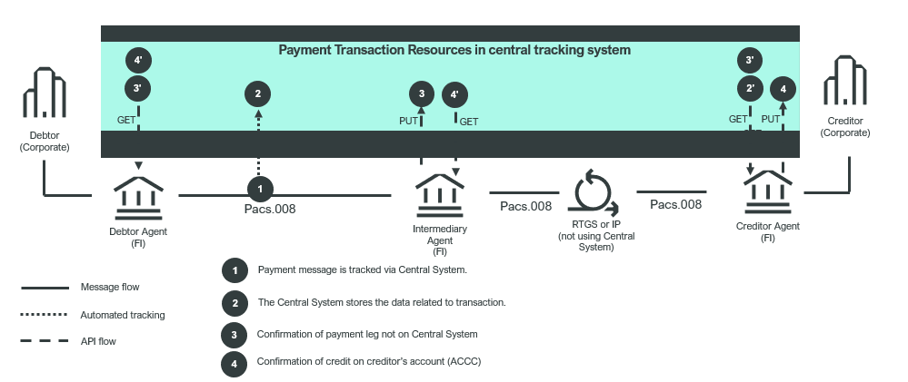

- Tracking of cross-border financial institution credit transfers where consumers of the resource data are FIs.
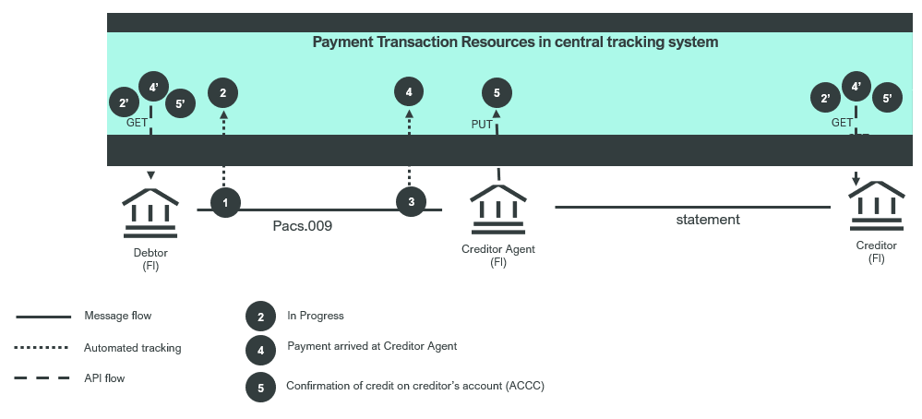

- Tracking of cross-border customer credit transfers where consumers of the resource data are FIs (and indirectly their corporate customers)
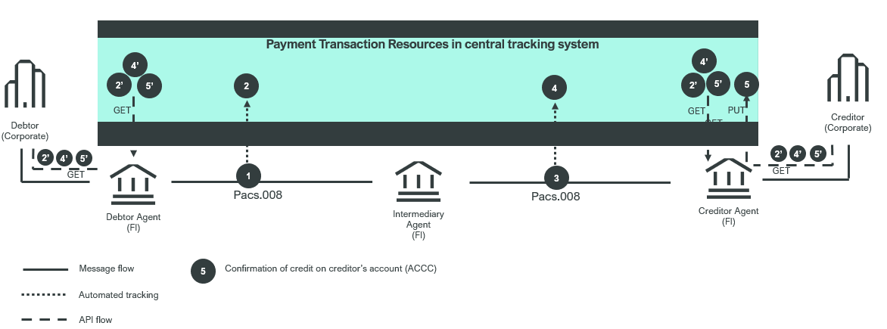

- Generic and simplified investigation flow via central system

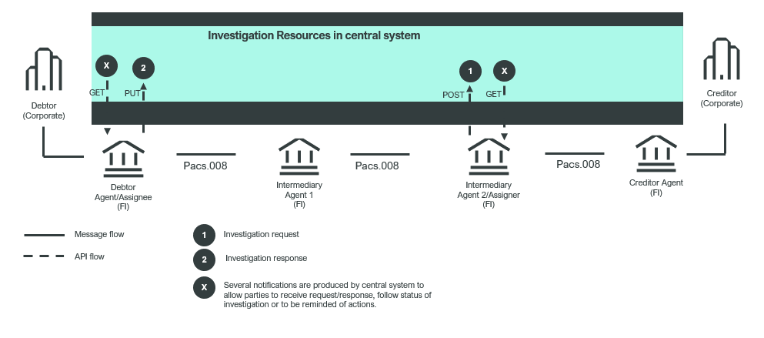
- Generic and simplified payment cancellation flow via central system (main function is stopping a payment as soon as cancellation is issued):

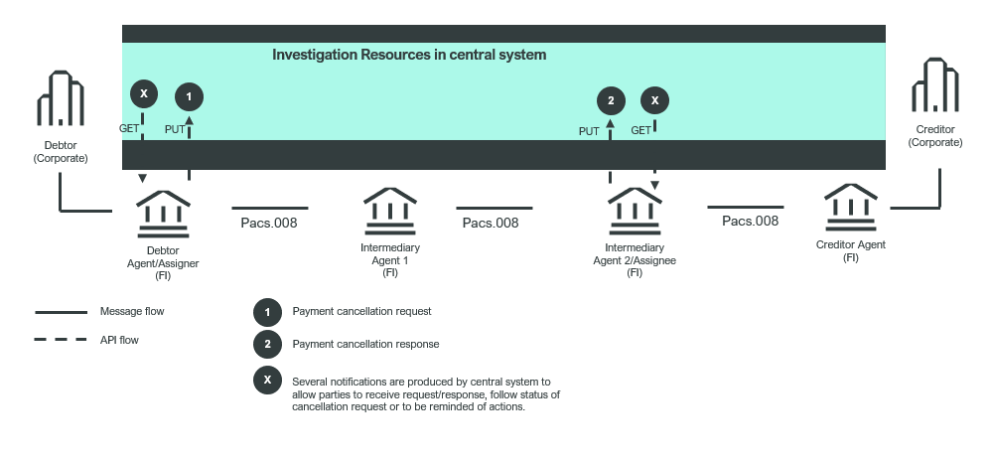

Resources to be foreseen:
- For the tracking of international payment transactions by the central system, supporting business flows 1, 2 and 3 above, two resources are foreseen:
  - ‘Status of transaction in the central system’ (where details are captured such as the transaction status, transaction status reason, etc, …)
  - ‘Payment events’ (where details are captured related to the individual events that compose a transaction tracking life cycle, such as payment transfer, pending-reject-credit confirmation updates to central system, etc, … )
Note: The above resources will make use of the credit transfer resources that have been submitted in the context of the Business Justification 220 (Credit Transfer API resources).
Note: the development of these resources needs to be linked to the BJ144 (Tracking Business Transaction) that was submitted for the registration of the trck messages as the trck messages partly share the same resource model.

- For the investigation management and orchestration by central system, supporting business flows 4-5 above, at least one resource is to be foreseen:
a. Generic ‘Investigation resource’ which includes attributes related to the investigation itself.
The purpose of the resource will be to capture details, responses and notifications related to the exception and investigation as well as payment cancellation business processes.
b. ‘Use case related attributes’ such as cancellation, debit authorisation, use of funds, compensation, etc…. Several resources required to support various use cases.
Note:
- The development and registration of this resource(s) should be linked to the BJ204 (Exception and Investigation modernization) and existing camt messages like camt.056, camt.029 as well as negative pacs.002s.
- Additional resources may need to be developed along the process.

Following actors might get direct or indirect access to the described resources (subject to the visibility rights linked to their role):
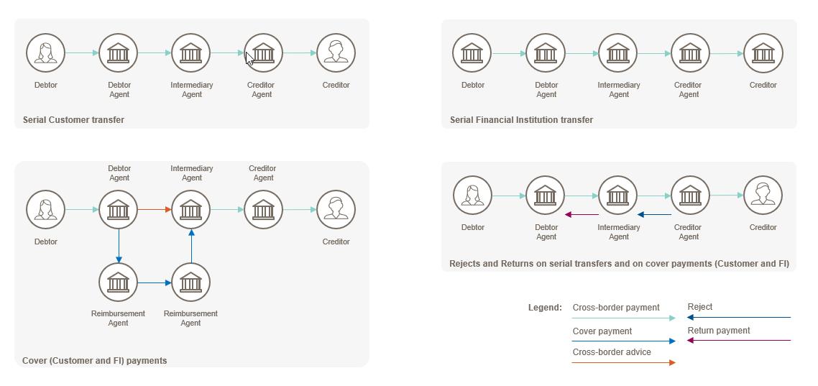
The submitting organisation sees no reason why these ISO 20022 API resources could not be used by other business domains, entities, and/or processes where payment transactions need to be tracked.
The submitting organisation will ensure that the repository items will be fully aligned with the existing ISO 20022 message definitions.

- Purpose of the new development:
Use of APIs is emerging in many steps in the payments value chain, from payment initiation to settlement and reporting. In many end-to-end payments business processes, APIs and financial messages – increasingly ISO 20022 messages – will be used together. The industry has spent many years and billions of dollars already in the effort to converge on a common messaging standard from a starting point of extreme fragmentation (and we’re not done yet).
We face creating a similar fragmentation problem in the use of APIs. Fragmentation introduces risk, cost and friction into end-to-end payments processes, without counterbalancing benefits. Use of APIs is evolving, as service providers compete to offer new products, so the industry needs a balanced approach to combat fragmentation without constraining innovation. Standardisation of a common generic API resource for payments, payments tracking and investigation processes, based on ISO 20022, promotes interoperability at the data level between the APIs and messages implemented by the multiple actors that together realize payments business processes. Benefits include ease of composing new business processes from existing services; preservation of structured data from end to end without truncation or loss of semantic precision; ease of integration with existing business processes, applications and infrastructure.

- Community of users and benefits:
- Benefits/savings:
As set out above, the benefit of standardization of a resource for APIs in the areas of payments, payments tracking and payment investigation management, is to avoid the frictions and inefficiencies of the fragmentation that would otherwise result as APIs proliferate.
- Adoption scenario:
As submitter, Swift undertakes to adopt the standard for central payments tracking and payment investigation management APIs developed for its community. Although many APIs already exist in the payments space, APIs specifically designed globally for these two areas are currently – as far as we know – only supported by Swift. In order to anticipate possible API implementations and potential fragmentation, it is key to evolve towards an API specification with a formally registered generic resource model, and that new API developments in these areas would also draw on a standard resource model as the best way to achieve interoperability and as a facilitator of adoption in their target markets.
- Volumes: for 2022, 200m+ API calls exchanged for payment tracking with expected increase of volumes in future. This figure does not include other areas like APIs exchanged in the context of central investigations.
- Sponsors and adopters: Cross-border payments tracked across 211 countries, 3200+ country corridors and 900 banking groups worldwide with appetite to use API likely to rise.

- Timing and development:
Swift believes that the risk of fragmentation in API specifications in the area of central payments tracking and payment investigation management is realistic and therefore supports that the industry addresses this problem through standardisation. Swift would aim to present a draft specification to the API and Payments SEGs, Q4/2026.

- Commitments of the submitting organisation:
Swift as submitting organisation confirms that it can and will:
- undertake the development of the candidate ISO 20022 API resource models that it will submit to the RA for compliance review and evaluation. The submission must be compliant with the ISO 20022 Master Rules and include a draft Part 1 of the ISO 20022 Resource Definition Report (RDR) compliant with the template for RDR part 1 provided by the RA and, optionally, examples of valid and invalid instances of each candidate ISO 20022 API resource.
- address any queries related to the description of the models and ISO 20022 API resources as published by the RA on the ISO 20022 website.
The submitting organisation confirms that it will promptly inform the RA about any changes or more accurate information about the number of candidate ISO 20022 API resources and the timing of their submission to the RA. If the submitting organisation does not submit the candidate ISO 20022 API resources within the timing announced in section F and does not inform the RA beforehand, the business justification may lapse and require re-submission of a new business justification for approval by the RMG.
The submitting organisation confirms it does not intend to organize any testing of the candidate ISO 20022 API resources once they have been reviewed and qualified by the RA and before their submission to the SEG(s), API SEG, BMST and/or TSG for approval.
The submitting organisation confirms it is committed to undertake the future maintenance of the ISO 20022 API resources.
The submitting organisation confirms its knowledge and acceptance of the ISO 20022 Intellectual Property Rights policy for contributing organisations, as follows.
“Organizations that contribute information to be incorporated into the ISO 20022 Repository shall keep any Intellectual Property Rights (IPR) they have on this information. A contributing organization warrants that it has sufficient rights on the contributed information to have it published in the ISO 20022 Repository through the ISO 20022 Registration Authority in accordance with the rules set in ISO 20022. To ascertain a widespread, public and uniform use of the ISO 20022 Repository information, the contributing organization grants third parties a non-exclusive, royalty-free licence to use the published information”.
- Contact persons:
Dominique Forceville (Swift/ dominique.forceville@swift.com)
Emma Saxton (Swift / emma.saxton@swift.com)

- Comments from the RMG members and relevant SEG(s) or SubSEG(s) and disposition of comments by the submitting organisation:
This section will include the comments received from RMG members and the SEG(s), SubSEG(s), API SEG, BMST and/or TSG, if any, and the response given to each of these comments by the submitting organisation.

Comments from the Swiss RMG delegation:
Submitter of comments: Rainer Vogelgesang, Martin Walder (Swiss RMG delegation)
Date: 28 June 2023
Commentary:
The Swiss Association for SWIFT and Financial Standards (SASFS) is the representative organisation for financial standardisation in the financial centre of Switzerland and Liechtenstein.
The Swiss RMG delegation jointly with the SASFS payments experts have evaluated BJ 222 and the proposed development of common generic Central Payment Tracking and Investigation Management API Resources.
The SASFS fully appreciates the initiative of SWIFT to move forward the standardisation in the area of tracking the delivery of messages and understands the stated motivation to combat fragmentation in light of the evolution of APIs and to promote interoperability at the data level between the APIs and messages.
In view of the stated aims, we do not immediately understand that the SO proposes for draft specifications to be submitted to the API SEG and Payments SEGs at the earliest in Q4/2026. Considering the typical SEG review cycle timelines, the published API resources will likely not become available before 2027 with a risk that unforeseen events might delay availability to 2028 or later with implications on subsequent implementation of these API resources most likely not before 2028.
We are concerned that, due to the fast-paced evolution in the API space, such long a timeline will not contribute to the state aim of combating fragmentation.
We wonder whether the SO could consider measures in order considerably to bring down the development timeline.
BJ 222 mentions interdependencies with earlier BJ 144 ‘Tracking Business Transactions’ and earlier BJ 204 ‘Exceptions and Investigations Request/Response message definitions’. Both related BJs have been approved by the RMG in 2019 and 2022, respectively, but, according to the information available on iso20022.org, have not moved forward yet to the next stage including a SEG review. The SO should consider whether an alternative approach could be considered where the development of API resources for central payment tracking (i.e. the first part of BJ 222) could be combined with the development stream of ISO 20022 messages for BJ 144 ‘Tracking Business Transactions’ and the development of API resources for investigation management (i.e. the second part of BJ 222) could be combined with the development stream of ISO 20022 messages for BJ 204 ‘Exceptions and Investigations Request/Response message definitions’.
Whilst BJ 144 aimed to start to migrate to the proposed new set of Tracking messages from 2021 with the legacy (MT) tracking messages expected to be retired by 2025, BJ 204 stated that the new messages would be required to be published in 2023 for wider community adoption in 2024.
The target timelines of BJ 144 and BJ 204 would lend themselves to combine the evaluation of ISO 20022 messages (BJ 144, BJ 204) and ISO 20022 API resources (BJ 222) in the pertinent SEG review cycles for the two business processes of Business Transaction Tracking and Exceptions and Investigations, respectively.
In light of the excessively long timeline for envisaged availability of the API resources of BJ 222 and the related risk of not being able to achieve the stated aim of avoiding fragmentation as well as the potential alternative approach of combing the review and evaluation of the API resources of BJ 222 with the corresponding candidate messages of earlier BJs 144 and 204, we object to BJ 222 in its current form in order to afford the SO the opportunity to reconsider BJ 222.
We look forward to the responses of the submitting organisation to the points raised and remain available for further considerations.

Reply to comment from the Swiss RMG delegation:
Swift has reviewed the internal delivery timelines and confirms that the submission of the API resources in relation to this BJ can be achieved for Q4/2024.
Thank you for the feedback/comments.

