**Business Justification**

**for the development of new ISO 20022 API Resource**

*Note: the purpose of this document is to give guidelines to organisations that want to develop new candidate ISO 20022 resource definitions. Such requests are subject to the approval of a business justification by the ISO 20022 Registration Management Group (RMG). Please consult the iso20022.org website for additional details on* [*the registration process*](http://www.iso20022.org/development.page)*. The business justification must include the following captions, as described. Business justifications are to be uploaded* [*at www.iso200222.org*](https://www.iso20022.org/erequest-forms)

1. **Name of the request:**

Corporate-to-bank Trade Finance Undertaking API resources

1. **Submitting organisation(s):**

Swift

1. **Scope of the new development:**

The proposed API resource encompasses the full lifecycle of a trade finance Undertaking in the corporate to bank space. This includes the application, amendments, extensions or pay, demands and reduction/release.

The ISO 20022 business area is Trade services and the TSEG should be aware of evaluation.

There are three resources foreseen:

* TradeFinanceUndertaking (includes requests, confirmation and advise of application, issuance, amendments, reduction, and release)
* Demand (includes Extend or Pay)
* Events which users can poll to retrieve new updates for information or for request for action

The customer journey of interacting with the Undertaking resource encompasses the full lifecycle of an Undertaking in the corporate to bank domain, as follows:

* Application for issuance of Undertaking
* update of undertaking data before issuance (i.e., change the initial application request based on a drafted undertaking text provided by the bank)
* Request for Amendment of Undertaking
* Acceptance / refusal response to a request for Amendment of Undertaking
* Advice of acceptance / refusal of request for Amendment of Undertaking
* Advice of issued Undertaking
* Advice of amended Undertaking
* Query to extend or pay Undertaking
* Response to extend or pay Undertaking
* Notification of Non-Extension of Undertaking
* Demand for payment under Undertaking
* Refusal of demand for payment under Undertaking
* Acknowledgment of demand for payment under Undertaking
* Settlement of Undertaking claim for payment and/or charges
* Request for Undertaking Reduction / Release
* Advice of Undertaking Reduction / Release

Here is the technical flow illustrating the different steps:

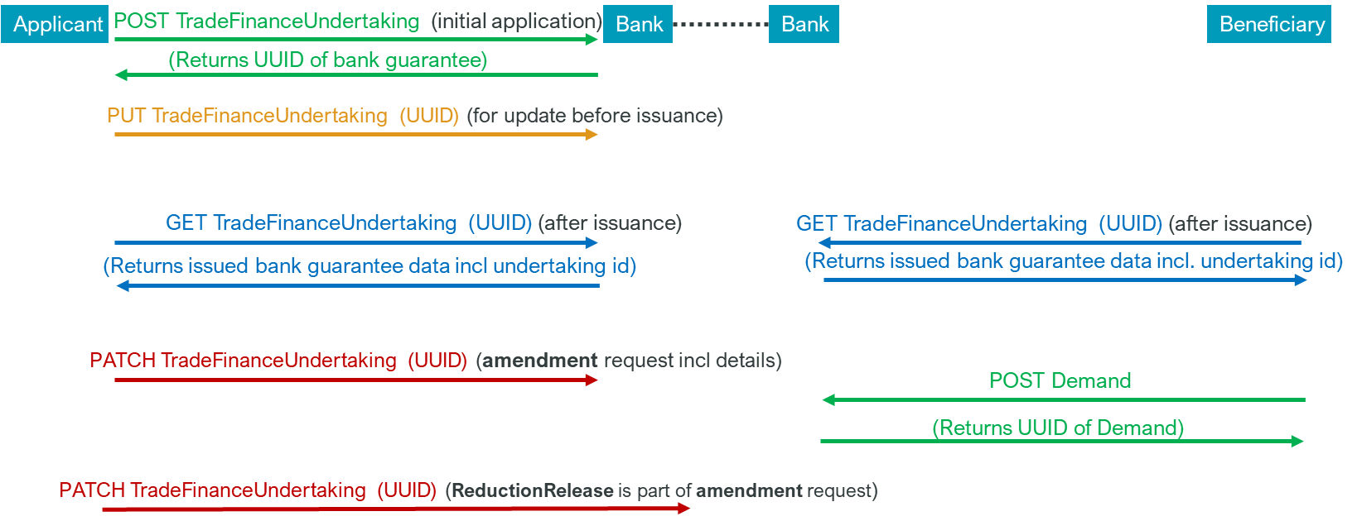

The Events resource will be used to send real time notification by the event producer. This is illustrated as follows:

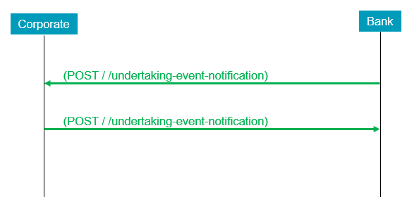

*In the above illustration, in the second step, the corporate can potentially respond with an acceptance or refusal as per the business request. In future, we expect the events resource to grow/expand to allow for more events related to other trade finance instruments like Documentary Letters of Credit.*

The resources have been created with input from members of the Swift. Global Trade Based API working group which comprises of global banks and customers. The functionality and data richness encompass largely what could be captured in the Swift MT 798 message (with some streamlining) and were built using various, flattened ISO 20022 components that were previously created for the already registered as ISO 20022 messages for bank guarantees, such as tsin.005, and tsrv.001 – 019. There is more space for extra information than in the MT 798 but aligned with the ISO 20022 messages. While the resource has already been created and is in a pilotable state, we welcome requests from the review committee to fill any remaining content gaps to make it truly global in usability.

This is an illustration of the top-level components of the Undertaking resource:

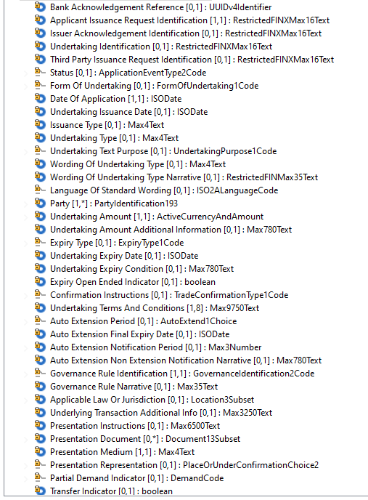

*In the above picture, the Party component is repeatable and contains all codes to identify different parties involved in an Undertaking life cycle.*

The aim is to pilot the resource on the Swift network in H2 2023, and after registration it will be available on the ISO 20022 website for use anywhere. The resource does not include security features, these are specific to the implementation channel.

There are no upstream flows, these C2B flows are part of the initial process. Downstream in the interbank space the data can be seamlessly mapped to ISO 20022 messages for Undertaking, or -possibly with narrative truncation- to interbank trade MT messages.

The Undertaking resource is (yet) not applicable to other business processes such as Documentary Letters of Credit, though a number of the elements and components might be reused in future trade finance-related ISO 20022 messages or APIs.

The Undertaking resource is not applicable to other ISO 20022 business domains.

1. **Purpose of the new development:**

The current solution in the corporate to bank space is based on the use of Proprietary Swift’s MT 798 unvalidated envelope messages for which a set of Undertaking message definitions were created.

The unvalidated MT 798 envelope message, coupled with its restricted space for additional supporting information, causes significant friction and reduces STP.

There is an appetite from corporates to replace the MT 798s with APIs rather than XML messages. However, the upmost importance is for the data to be easily integrated into the current back-office systems/setups.

Therefore, these API resources re-use many elements from bank guarantee related interbank ISO 20022 messages. In addition, attention was also spent to align party information with CBPR+.

The supporting Events resource can in the future be extended to include other trade related events like documentary letters of credit.

1. **Community of users and benefits:**

The global bank guarantee market was valued at $20.28 billion in 2020 and is projected to reach $41.48 billion by 2030 (source: Allied market research)

Swift traffic of relevant MT798 messages has doubled in the last 3 years, growing even quicker than the market.

The above observations show the increasing importance of the bank guarantee market which can benefit from these APIs no matter the channel.

It is timely to offer this modern, scalable solution using formal structures instead of envelope messages.

In the interbank space, to forward the data, currently MT messages can continue to be used, however this can be the push/incentive to move interbank bank guarantee messages to the already registered ISO 20022 messages which are well aligned with the API resource; or envisage an ISO 20022-aligned interbank API solution.

1. **Requested additional deliverables from the Registration Authority**

The submitting organization proposes to deliver on top of the API resources a sample implementation in the form of an OAS3 contract for better understanding.

1. **Commitments of the submitting organisation:**

The submitting organisation must confirms that it can and will:

* undertake the development of the candidate ISO 20022 Resource(s) that it will submit to the RA for compliance review, registration and publication. The submission must be compliant with the [ISO 20022 Master Rules](http://www.iso20022.org/documents/general/ISO20022_MasterRules.ZIP). Once approved by the RA, the new resource(s) will be registered in the ISO 20022 Repository and published by the RA together with the RDR (generated by the RA).
* undertake the development of a web service API solution based on ISO 20022 Resources and using the ISO 20022 API modelling guidelines; the RA will not review, register or publish the API calls, but provides a page on iso20022.org where ISO 20022 API solutions can be referred to.
* address any queries related to the description of the Resource as published by the RA on the ISO 20022 website.

The submitting organisation confirms its knowledge and acceptance of the ISO 20022 Intellectual Property Rights policy for contributing organisations, as follows.

*“Organizations that contribute information to be incorporated into the ISO 20022 Repository shall keep any Intellectual Property Rights (IPR) they have on this information. A contributing organization warrants that it has sufficient rights on the contributed information to have it published in the ISO 20022 Repository through the ISO 20022 Registration Authority in accordance with the rules set in ISO 20022. To ascertain a widespread, public, and uniform use of the ISO 20022 Repository information, the contributing organization grants third parties a non-exclusive, royalty-free licence to use the published information”.*

1. **Contact persons:**

Mukta Kadam – [mukta.kadam@swift.com](mailto:mukta.kadam@swift.com)

Tom Alaerts – [tom.alaerts@swift.com](mailto:tom.alaerts@swift.com)

1. **Comments from the RMG members and relevant SEG(s) or SubSEG(s) and disposition of comments by the submitting organisation:**

This section will include the comments received from RMG members and the SEG(s) or SubSEG(s), if any, and the response given to each of these comments by the submitting organisation.

**Deadline for first comments: 8th March 2023.**

**Comments from the Swiss RMG delegation:**

*Swiss Association for SWIFT & Financial Standards*

*Hochstrasse 20 - CH-8330 Pfäffikon ZH - geschaeftsstelle@sasfs.ch*

*T: +41 79 941 30 87 Homepage: [www.sasfs.ch](http://www.sasfs.ch)*

*Secretariat: Swiss Association for SWIFT & Financial Standards, Hochstrasse 20, CH-8330 Pfäffikon ZH - E-Mail: SASFS Secretariat <geschaeftsstelle@sasfs.ch>*

*C2B* Bank Guarantee** API resources*

*Submitter of comments: Rainer Vogelgesang (head of* *Swiss RMG delegation)*

*Date: 07 March 2023*

Commentary

The Swiss Association for SWIFT and Financial Standards (SASFS) is the representative

organisation for financial standardisation in the financial centre of Switzerland and Liechtenstein.

The SASFS welcomes the initiative of SWIFT as submitting organisation (SO) of this BJ to move forward, in consultation with the members of the Swift Global Trade Based API working group, the ISO 20022 standardisation in the bank guarantee space. In general, we support the BJ and the request to develop the ISO 20022 API resources proposed.

We believe that, for starting the ISO 20022 standardisation in the bank guarantee space, the

customer-to-bank interaction is a suitable area of focus.

There are a number of details, stated in the BJ, for which we would appreciate feedback and, if applicable, consideration for amendments in a new version of the BJ as follows:

1. Concern related to limiting the scope to bank guarantees

The number of domestic contingent undertakings, such as bank guarantees, is by far higher

than the number of international undertakings.

Such domestic undertakings are executed differently in different markets: in some

countries/markets in the legal form of bank guarantees, in other countries/markets as Stand-by Letters of Credit and again in many countries as sureties.

By limiting the scope to bank guarantees, the use of the standard will be limited to a smaller

part of all undertakings applied for. As a consequence, there is a risk that other standards

will emerge for the domestic and non-bank guarantee cases and the implementation of the

messages covered by BJ 215 may remain limited. Banks will primarily strive to implement

solutions for the bigger volumes, i.e. the domestic transactions.

Swift: We think, we weren’t clear in the BJ that the solution is also applicable to Stand-by LCs. We have updated the BJ accordingly.

We believe that the application processes for bank guarantees, Stand-by Letters of Credit

and sureties are much the same (exactly the same in Switzerland), what is different is the

handling of the issuance process of these instruments in the banks.

Therefore, although we see that limiting the scope to bank guarantees reduces complexity,

we believe many banks will only implement solutions covering the larger part of their

business which usually are domestic undertakings. They may not use the standard if their

need is not covered.

Swift: In general, having API Standards for international undertakings can be the first step and as we progress, we can look at the domestic use cases which can be complex and supremely dependent on local market practices, regulatory policies etc. Also, when the resource is shared with the members, we can jointly discuss on what’s missing or needs improvements.

2. Scope amendments

In chapter ‘C. Scope of the new development’ we would recommend the following

amendments to be considered:

a. The second sentence should be clarified as follows: “… amendments, demands

(including extend or pay demands) and final release.”

Swift: Ok, we have modified the sentence to include ‘extend or pay’.

Swift: The ‘ReductionRelease’ resource takes care of both – reduction and release processes.

b. The four resources should be specified as follows:

“There are four resources …

- Issuance and amendments (including undertaking text drafting process,

application, request for amendment and confirmation of issuance and

amendment)

- Demand[/claim] (including extend or pay)

- Reduction and release

- Events …”

Swift: Ok, we have modified the text.

c. The outline of the customer journey should refer to ‘undertaking’ in order to be able

to consider, for inclusion in the scope, also Stand-by L/Cs and sureties, in addition to

Bank Guarantees. Thus, it is proposed to phrase the customer journey as follows:

“The customer journey …

- applicant applies for the issuance of an undertaking

- applicant can update undertaking data before issuance (i.e. change the

initial application, among others based on a drafted undertaking text

provided by the bank)

- applicant can retrieve undertaking data after issuance

- applicant can request amendments to the undertaking

- bank can submit beneficiaries extend or pay request

- bank can inform about demands[/claims] received and payments effected

- bank can inform about acceptance or refusal of amendments by the

beneficiary

- bank can inform about release from obligations under the undertaking

received from beneficiaries”

- applicant can transmit agreement or non-agreement to extend request

- applicant can request reduction or release of the undertaking

- applicant can request payment in reduction of the undertaking”

Note: It is not to the applicant to decide whether a demand is accepted or not.

Swift: Updated to ‘Undertaking’.

Swift: Journey modified as per the suggestion above.

Swift: Agree on the note.

3. Title of BJ

The SO should clarify whether the asterisks embedded in the title of the BJ (C2B* Bank

Guarantee** API resources) refer to some footnotes which may have gone missing. If not, it

would be recommended to remove such asterisks to avoid confusion.

We look forward to the responses of the SO to the points raised above and remain available for further considerations in relation to this work item.

Swift: The asterisks are clearly explained in the document. We have also changed the title name to make it clear for a reader.

**Comments from the Danish RMG delegation:**

Generally, we highly support the creation of standardized API’s in the ISO regime between corporate and bank. It will allow us to integrate directly with corporates (or third parties also adopting the same standards) through standardized integration rather than tailored direct or indirect integration. It should be done for all traditional trade finance products.

To the Business Justification document, we have the following comments:

1. Drafting of guarantee wording between applicant and issuing bank pre-issuance
   1. Issuing bank must be able to push a guarantee wording draft to the applicant (repeatable) Swift: This is indeed repeatable.
   2. Applicant must be able to push a negotiated guarantee wording draft to the issuing bank (repeatable)

Swift: This feature* already exists – we will clearly explain in the BJ again for clarity. The applicant can PUT as many times as required until the wording is FINAL. There are codes in the resource to indicate DRAFT or FINAL. *If ‘negotiated’ means – agreed wording between the applicant and the issuing bank.

1. Drafting of guarantee wording between applicant and issuing bank pre-amendment
   1. Issuing bank must be able to push a guarantee amendment wording draft to the applicant (repeatable)

Swift: This feature is not available today in both MT 798s and the registered ISO 20022 trade services messages. Can be discussed in the Trade SEG.

* 1. Applicant must be able to push a negotiated guarantee amendment wording draft to the issuing bank (repeatable)

1. Post-issuance, in the current drawing it is up to the beneficiary to trigger the API, though they may not know when to trigger. We understand that this is as per design, though we think it can be improved when the beneficiary gets a notification (or similar) of guarantee issuance through APIs.

Swift: A party can check for news regularly OR in case the end parties have servers, then the banks can post these.

1. API’s should replace the fileACT channel, by adding attachments to the same API call.

Swift: The SWIFT API team is indeed looking at a solution to transfer big attachments using APIs. However, for this ISO submission, we preferred to leave attachments out of the payload since the limits on size posed by different servers. In general, it is best practice that file transfer is a solution on its own, that this can refer to.

1. Amendment should include components for typical amendment types, such as ‘Change of guarantee type’, ‘Change in currency’, ‘Change in Customer/subsidiary’, etc.

Swift: We think these are special cases and not regular ones.

Regarding change of guarantee type, as a practice, if such business cases appear, they are handled by issuing an entirely new undertaking.

A change of currency is usually needed when there was a mistake during the issuance and we believe, this would be only a handful of cases.

Change in ‘beneficiary’ is allowed by the resource.

**Comments from VISA delegation:**

* in the PPT flow diagram, the new business justification approval process, some review timelines are mentioned in days some in weeks some in months. Shall it be better to follow single timeline category (say working days) ?

Swift: Sure, feedback for the RA. @ISO20022RA?

* Is there any way we can get the schema file(.xsd) for “Resources for Corporate to Bank Guarantee” APIs? I see only the top-level components of the bank guarantee resource in the document, just want to glace through the elements and attributes, how many level are defined in the object?

Swift: Yes, as soon as the draft is ready, we will share.

* Is Get APIs provides list or latest version of bank guarantee or demand or reduction release? Reason for this question is, I see a PATH API, it means some fields are modified, is system will maintain old version and new version of event?

Swift: A GET would be the latest version. And the back offices can track the lifecycle of the previous events.

**Deadline for additional comments: 02 May 2023.**

**Comments from the Swiss RMG delegation:**

**Submitter of comments:** Rainer Vogelgesang (head of Swiss RMG delegation)

**Date:** 28 April 2023

**Commentary:**

The Swiss Association for SWIFT and Financial Standards (SASFS) is the representative organisation for financial standardisation in the financial centre of Switzerland and Liechtenstein.

The SASFS welcomes the initiative of SWIFT as submitting organisation (SO) of this BJ to move forward, in consultation with the members of the Swift Global Trade Based API working group, the ISO 20022 standardisation in the bank guarantee space.

We value the dispositions of the submitting organisation related to the comments of RMG delegations and appreciate that most of our Swiss comments have been considered.

However, there remain a number of important details which we find difficult to agree with. We disagree with keeping the scope to guarantees/Stand-by L/Cs but not to sureties.

For most banks, domestic business is more important than the cross boarder business and many countries do mainly sureties in domestic business. Excluding the request for sureties in the API will largely reduce adoption potential as banks budgets in Trade Finance field are very limited so that they will firstly concentrate on the domestic business if they have to decide between domestic and international solutions.

Even bank-to-bank MT 76x messages care for requesting sureties.

We fully share reservation when it comes to transmit surety instruments issued but believe that the request for sureties and guarantees is very similar.

**Swift:** Thank you for the feedback. We have now updated the BJ to extend the scope to Dependent Undertakings.

Regarding the resources, the BJ states as follows:

*There are four resources foreseen:*

* *BankGuarantee (includes requests and confirmation of application, issuance, amendments)*
* *Extend or Pay*
* *Demand*
* *Reduction/Release*
* *Events which users can poll to retrieve new updates for information or for request for action*

However, there are 5 resources listed now.

We believe four resources should be correct since “Extend or pay” should not be a resource but is a form of a demand, since “pay” can only happen against a complying demand (same as in MT 76x messages)

Therefore, it should read:

There are four resources foreseen:

* Undertaking (includes requests and confirmation of application, issuance, amendments)
* Demand (including “extend or pay”)
* Reduction/Release
* Events which users can poll to retrieve new updates for information or for request for action

While one could argue that a reduction is a form of amendment, same as cancellation before expiry date.

Although you state agreeing to the fact that it is not the applicant to decide about acceptance of an extend or pay demand, you keep the description of the journey as:

* *applicant can accept extend or pay request*

This implies that the applicant could also agree to the pay part. However, in case of an extend or pay demand, as issuing bank, we only request the applicant whether they want us to amend (extend) the validity of the undertaking. If the applicant does not, we will check whether the demand is compliant and either refuse the demand or pay the demand without requesting agreement from the applicant.

Therefore, we propose the wording as:

* applicant can transmit agreement or non-agreement to extend request under an “extend or pay” demand

Swift: We have updated the BJ as per the suggestion. Since the resource is in evolution stage, the resources underwent quite a few enhancements and therefore, there are only 3 resources to take care of the lifecycle.

We strongly support the creation of standardised APIs including the ones proposed in the relationship between applicant/instructing party and issuing bank particularly if they cover the request of sureties as well.

We look forward to the responses of the SO to our second set of points raised above and remain available for further considerations in relation to this work item.

**Comments from the Danish RMG delegation:**

**Submitter of comments:** Kitta Flyvholm Larsen

**Date:** 01 May 2023

**Commentary:**

With regards to BJ215 – C2B Bank Guarantee API, and the reply from Swift (is this RA or Swift as a member?) to the Danish comment on Charge (please see below)

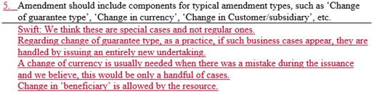

The Danish community strongly recommend that the API design is careful with assuming/defining limitations. In order to reach a high rate of (corporate and bank) adoption, you must allow for flexible solutions that cover as many business/customer scenarios as possible.

We have seen countless of scenarios where a corporate customer rejected the issuance of a new undertaking, but rather an amendment should be issued. If such scenarios are not covered by API design, adoption will become more difficult.

**Swift:** Considering the risk involved with changing for example currency, we think the best practice is to cancel and reissue a new undertaking. However, technically the resource allows for such amendments if corporate and bank insist.

**Comments from the French delegation:**

**Submitter of comments:** Laurent Lafeuillade

**Date:** 07 July 2023

**Commentary:**

The NMG "Trade" French working group (chaired by Patrick in cc of this email) has no objection on the submission of the business justification on this new Guarantee API resource.

We still have a few comments on the BJ and the previous feedbacks:

* In the list of flows, we do not see the bank to corporate flows to notify the client on his request, such as issuance, amendment or release. We can only see applicant requests and advices to beneficiary. Can they be added, to make the scope clear for all parties?

**Swift:** The response or notifications are taken care of through the ‘Events’ resource. The ‘Events’ resource comprises of event types and status codes which help indicate the business response. Some of the events are – ‘APLA’ for Application Issuance Advise, ‘AMNR’ for Amendment Response etc.

* For the Events (POST), does it cover the notifications of events described in the previous list of flows (such as amendments or release requests) or it is covering other events not listed previously?

**Swift:** These codes are indeed foreseen to cover all the expected events as mentioned in the flows.

* As mentioned by the Danish community, we feel that FileAct channel should be replaced asap in the API resource to ease the implementation on corporate side. Indeed, FileAct configuration is one of the main issues faced by corporates deploying MT798 today. To keep this constraint may limit the adoption by the industry.

**Swift:** Valid comment. We do not want to limit the supporting documents infrastructure to FileAct, it is one of the methods foreseen. The documents will not be embedded however, that would generate issues with gateway capacity etc. You can give more detailed feedback when reviewing the resource.

* Regarding the last suggestion on the possibility to amend all data of the guarantees, we are not in favor of amending the currency of the guarantee. For this specific case, as suggested by Swift, we recommend recreating a new guarantee.

**Swift:** We agree. Considering the risk involved with changing for example currency, we think the best practice is to cancel and reissue a new undertaking.