Change Request
for the update of ISO 20022 financial repository items
- Origin of the request:

A.1 Submitter:
Banco Central do Brasil (Central Bank of Brazil)

A.2 Contact person:
Liliane Dutra: liliane.dutra@ipmfglobal.com.br + 55 11 98542-4421
Fernanda Pedroso: fernanda.pedroso@bcb.gov.br +55 51 3215-7309
Fernando Cavalcanti: fernando.cavalcanti@bcb.gov.br +55 61 3414-2589
Maurício Honda: mauricio.honda@bcb.gov.br +55 11 3491-6342
Rojane Perdigão: rojane.abranches@bcb.gov.br +55 31 3253-7149

A.3 Sponsors:
ABNT CEE-112 Brazilian Standards Committee

- Related messages:
Business Domain Payments, Payments Mandates Message Set:
- pain.009.001.07 MandateInitiationRequestV07
- pain.010.001.07 MandateAmendmentRequestV07
- pain.011.001.07 MandateCancellationRequestV07
- pain.012.001.07 MandateAcceptanceReportV07
- pain.017.001.03 MandateCopyRequestV03
- pain.018.001.03 MandateSuspensionRequestV03

- Description of the change request:
  - Inclusion of Supplementary Data with MandateStatus in the pain.012.001.07 MandateAcceptanceReportV07.
  - Inclusion of Supplementary Data with MandateProcessingDetails in all the listed messages.
Mandate Status:
There is a time gap between the reception of the request by the Debtor Agent and the acceptance or rejection of the request by the Debtor. However, the response message for initiating, amending, cancelling, or suspending Mandates only allows you to inform whether the request was accepted or rejected, and thus can't be used to first inform the reception of the request and then later it’s the acceptance or rejection.
The inclusion of the MandateStatus element would allow the inclusion of the Debtor’s consent status on the mandate request as well as other intermediate status. This status information will be shared between the Debtor and Creditor Agents (Pix participants) and must be defined from a list of proprietary domains - to be further detailed - providing some of the following positions: 'request received and pending confirmation by the Debtor', 'request confirmed by the Debtor', 'request received and confirmed by the Debtor and the Creditor', 'request rejected by the Creditor', among others.

Element | Mult. | Type
MandateStatus | [1..1] | CodeSet

Mandate Processing Details:
The communication between participants in an instant payment system requires the identification of the date and time when the request is sent and then processed, since operations must be initiated and carried out under a tight deadline. However, the current version of the Mandates message set does not contain a message element for the date and time when the request is sent or responded.
The inclusion of the MandateProcessingDetails element in the messages listed under “Related messages” would provide information about date and time in several steps of the authorization/consent flow process, as well as amendment and cancelation flows. The list below provides some of the possible timestamps to be included in the messages:
- Creation of mandate by the Creditor or the Debtor Agent;
- Request for acceptance or rejection of a mandate, sent by the Creditor Agent to the Debtor Agent;
- Request for amendment of a mandate, sent by the Creditor Agent to the Debtor Agent;
- Request for cancellation of a mandate;
- Update of acceptance or of rejection of a mandate.

Element | Mult. | Type
MandateProcessingDetails | [1..*]
MandateProcessingType | [1..1] | CodeSet
ProcessingDateTime | [1..1] | ISODateTime

- Purpose of the change:
The Central Bank of Brazil (BCB), in the context of the Pix evolving agenda, is developing a new solution to enable recurring automatic payments upon prior authorization of the payer, without the need of any further action at each new transaction. This solution, so far called "Automatic Pix", aims to address several gaps that currently exist in the local market, providing convenience for users.
The objectives of Automatic Pix are: to achieve greater efficiency in the market, through the implementation of direct debit system in Pix; to stimulate competition, with the provision of the service to all participants on equal terms; to expand access to direct debit for companies of all sizes and reduce their costs; to increase the possibilities of payment means to users, augmenting the breadth of use cases served by Pix; to strengthen the use of Pix by businesses and to increase the convenience of use on Pix.
The solution under development includes a robust and convenient authorization system for the payer, with facilitated cancellation dynamics. This facilitates the management of recurring payments for Creditors and eliminates the need to establish multiple agreements to provide recurring payment services. It also stimulates competition and enables the use of the service by a greater number of payers and receivers.
In addition, Automatic Pix will allow new use cases, benefiting payment service providers (PSP's) and users.
For the Brazilian model of recurring payments under Automatic Pix, it is necessary that the messages currently used to support the payment mandates includes additional status and timestamp elements. This is an essential measure to guarantee the security of the confirmation process. The possibility to update status information on the mandates will allow the Pix participants to have the control to authorize recurring debits, confirming their origin, and reducing errors. Thus, this measure can also minimize fraud risks and undue approaches which can compromise Pix’s image. For this reason, participants need to have the updated information about the status (synchronized) to control the periodic debits, avoiding losses for any of the involved agents.
In the same way, mandate data may have amendments or cancelation. The flows are not presented in this change request, although the messages (pain.010 and pain.011) must be covered by the same proposed changes. At both processes, the information about changes in the mandate data will be updated through pain.012, sent from the Debtor Agent to the Creditor Agent (after acceptance or rejection by the Debtor) and stored in their systems.

- Urgency of the request:
The proposal is to include these elements as Supplementary Data, justified by the immediate need of the instant payment system in Brazil (Pix), in order to develop the operational manuals and the technical specification of the product, that will be launched in April 2024.
In addition, it is widely known that changes in the elements of the message structure can have negative impacts on the other jurisdictions that already use these messages. If any other community, besides Brazil, recognizes a benefit of using the requested new elements, we will request the inclusion of this information in the block of structural elements of the mandate for the next message revision cycle.

- Business examples:
The Automatic Pix model covers several stages (figure below). For this change request we focused on the first stage of Automatic Pix, which is the mandate consent, based on an authorization that is granted by the Debtor to the Debtor Agent. Mandate amendment and mandate cancellation follows the same logical information for the authorization and will also be covered by this change request.
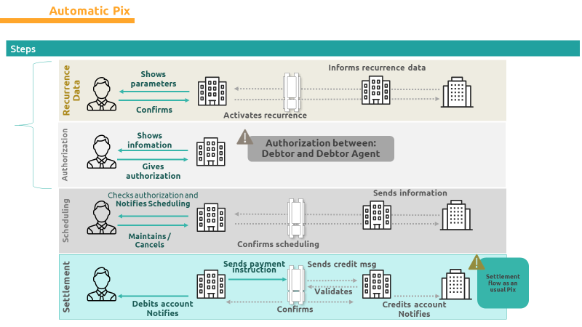
The Central Bank of Brazil – BCB is responsible for providing infrastructure for the transmission of the initiation message. According to this process, even if the Creditor and the Debtor have a relationship outside the Pix ecosystem, Automatic Pix will only be validated when the Debtor confirms the acceptance to the Debtor Agent, under authentication. The confirmation, which must be a part of a mandate, will be sent from the Debtor Agent to the Creditor Agent through a ‘pain’ message. After this action, the Debtor Agent will check whether the Debtor’s account is authorised for the recurring charges.
Prior to the payer’s acceptance or rejection, the recurrence must be created in the Creditor Agent’s systems. Recurrence contains the following information:
- Agreement data: contract number, description, number of occurrences, debt amount, collection date.
- Debtor data: CPF/CNPJ and name/identification.
- Ultimate Debtor data: CPF/CNPJ; name/identification; Debtor Agent; agency and account.
- Creditor account: CPF/CNPJ; name/identification; Creditor Agent.
- Recurrence data: ID (identification); request for acceptance/rejection of a mandate; status ID; Status (pending of Debtor’s confirmation); date time of creation.

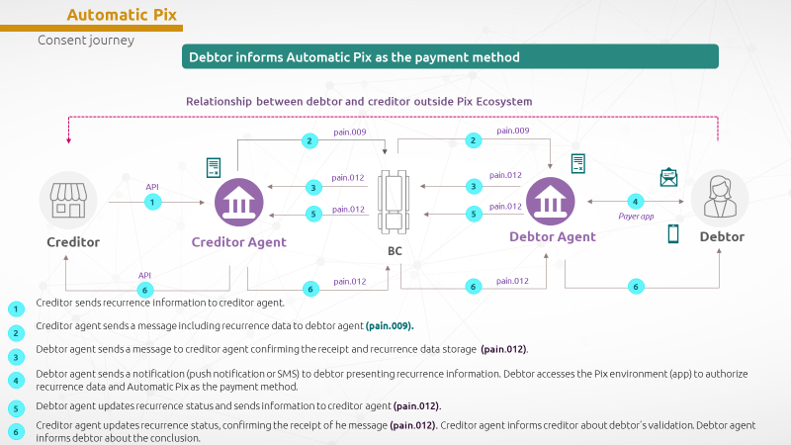

According to the flowchart above, the Creditor will send the recurrence information to the Creditor Agent through its automation or API. The recurrence is created by storing this data in the Creditor Agent’s systems. Information about date/time of its creation is required. All this data will compose the message for the mandate confirmation request (pain.009) to be sent from the Creditor Agent to the Debtor Agent. At this moment, pain.009 message will carry the status “pending confirmation”, as it has not yet been presented for Debtor’s validation (step 2 of the flowchart).
The Debtor Agent receives pain.009 with the status “pending confirmation” and stores the recurrence data to give knowledge to the Debtor. As a response, the Debtor Agent sends a message to confirm the receipt to the Creditor Agent with the same status (pain.012 – step 3).
After submitting the mandate data to the payer (step 4), the Debtor Agent collects the confirmation or rejection and updates the information with a new status (confirmed or rejected), accompanied by the date/time (step 5). All the information is stored on the Debtor Agent’s system that sends a message pain.012 to the Creditor Agent with this new status content (step 6).
On step 6, the Creditor Agent sends another confirmation message back to the Debtor Agent after it confirms the acceptance or rejection of the request, in order to ensure the symmetry of the Mandate information between both agents, assisting in the information reconciliation process.
As already mentioned, the Mandate request will have a deadline for the Debtor Agent's response, and if the Mandate confirmation is sent after this deadline, it may be rejected by the Creditor Agent. The message sent by the Creditor Agent informs that the response was received, registered and is valid as of the date and time of the confirmation.
Once the Creditor Agent receives the message and stores the new status, both the Debtor and Creditor are informed about the result of the full process flow. This is a required condition for the recurring payments. On the other hand, if the mandate is rejected by the payer, debits will not follow the Automatic Pix path.

SEG/TSG recommendation:
This section is not to be taken care of by the submitter of the change request. It will be completed in due time by the SEG(s) in charge of the related ISO 20022 messages or the TSG for changes related to the BAH.

Consider |  |  | Timing
- Next yearly cycle: 2024/2025
(the change will be considered for implementation in the yearly maintenance cycle which starts in 2022 and completes with the publication of new message versions in the spring of 2023)
- At the occasion of the next maintenance of the messages
(the change will be considered for implementation, but does not justify maintenance of the messages in its own right – will be pending until more critical change requests are received for the messages)
- Urgent unscheduled
(the change justifies an urgent implementation outside of the normal yearly cycle)
 |  |  | - Other timing:
Comments:

Reject
Reason for rejection:

CPF is the acronym for Individual Taxpayer Registration and is an identification issued by the Brazilian Federal Revenue Service. It is a unique number for each Brazilian citizen.
CNPJ is the acronym for National Register of Legal Entities. It is a unique number issued by the Brazilian Federal Revenue Service, which identifies a legal entity and other types of legal arrangement (public bodies, condominiums, funds).

