Business Justification
for the development of new ISO 20022 financial repository items

- Name of the request:
Triparty Collateral Management.
- Submitting organisation(s):

S.W.I.F.T. SCRL
Avenue Adèle 1
1310 La Hulpe
Belgium

Banco de España
C/ Alcalá, 48
28014 Madrid
Spain

- Scope of the new development:

The scope of this business justification is the reverse engineering of ISO 15022 Triparty
Collateral Management messages (MT 527, 558, 569) and the submission to the ISO 20022
Registration Authority of equivalent ISO 20022 compliant Business Transactions and
Message Sets. It will also be the opportunity to include additional functionalities in the ISO 20022 messages that are currently missing in ISO 15022 (e.g. removal of a financial instrument from the collateral pool) and to simplify the structure of some of the messages without removing any existing functionalities.

Triparty Collateral Management Messages

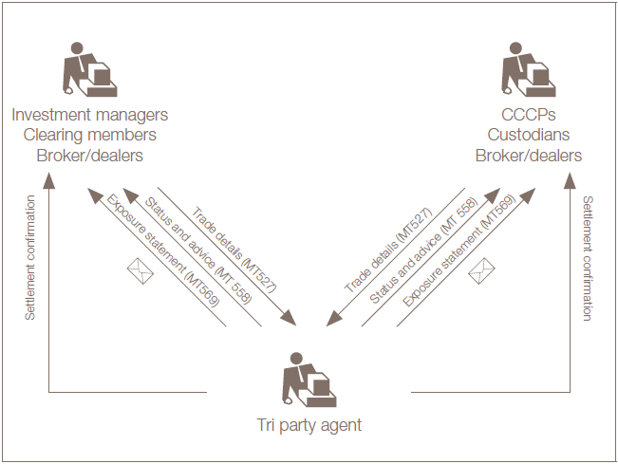

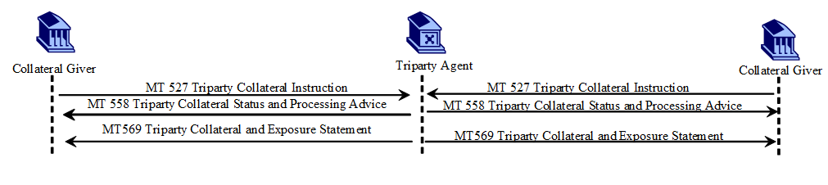

Financial Instruments | All instruments covered by the Classification of Financial  Instrument [CFI] standard (ISO 10962).
Business area | Collateral
Business Processes | Triparty Collateral Transaction Instruction  Triparty Collateral Status and Processing Advice  Triparty Collateral Transaction Allegement Notification  Triparty Collateral and Exposure Report  Cancellations and/or reversal for the above  Collateral Management Cancellation StatusAdvice  Removal of a financial instrument attribute from the collateral pool ( + termination)  Removal Response (rejection or confirmation)  Removal Cancellation

In view of the scope, the submitting organisations recommend that a dedicated evaluation team under the Securities SEG be assigned to the evaluation of the candidate ISO messages, once developed.
The use of the ISO 20022 Business Application Header (BAH) is mandated by the submitting organisations and therefore the elements present in the BAH (head.001.001.01) will not be repeated within the proposed messages.

The models created for these messages will generate messages in XML syntax.

- Purpose of the new development:

In 2017, the AMI-SeCo agreed to foster the integration and efficient functioning of collateral management while taking into account the ongoing work on the Eurosystem Collateral Management System (ECMS) and invited the HSG to establish a comprehensive list of collateral management harmonisation activities (CMHA), one of them was for Triparty Collateral Management messaging.
The Users of Triparty Collateral Management Services and the Triparty Collateral Management Service Providers such as TPAs and (I)CSDs should use harmonised ISO20022 messaging for triparty collateral management with ECMS which will be replacing the 19 Eurosystem NCB’s Collateral Management Systems.

Today triparty collateral management involves a series of specific triparty messages that manage high volumes of collateral transactions. The triparty messages are currently in ISO 15022, but they are not used consistently (see table 1 regarding differences in content and use of triparty messages). It is noted that as of yet there has been no triparty collateral management messages developed in the ISO 20022 Catalogue of Messages but the development of such messages are anyway a necessity to facilitate general migration of the securities industry to the ISO 20022 standard.

Table 1: Overview of triparty messaging
Currently, most institutions use triparty collateral management messages based on ISO 15022, e.g. involving triparty messages for trade details (MT 527), status and advice (MT 558) and exposure statement (MT 569)
A distinction could be made between
- Traditional triparty: This involves the UCMS and a TPA at the start and during the trade.
- Triparty with basket based liquidity trading: This involves the UCMS, ATS (Automated Trading System), CCP and a TPA.
There are other triparty types/models (such as SIX triparty) but this is not covered under the below example.
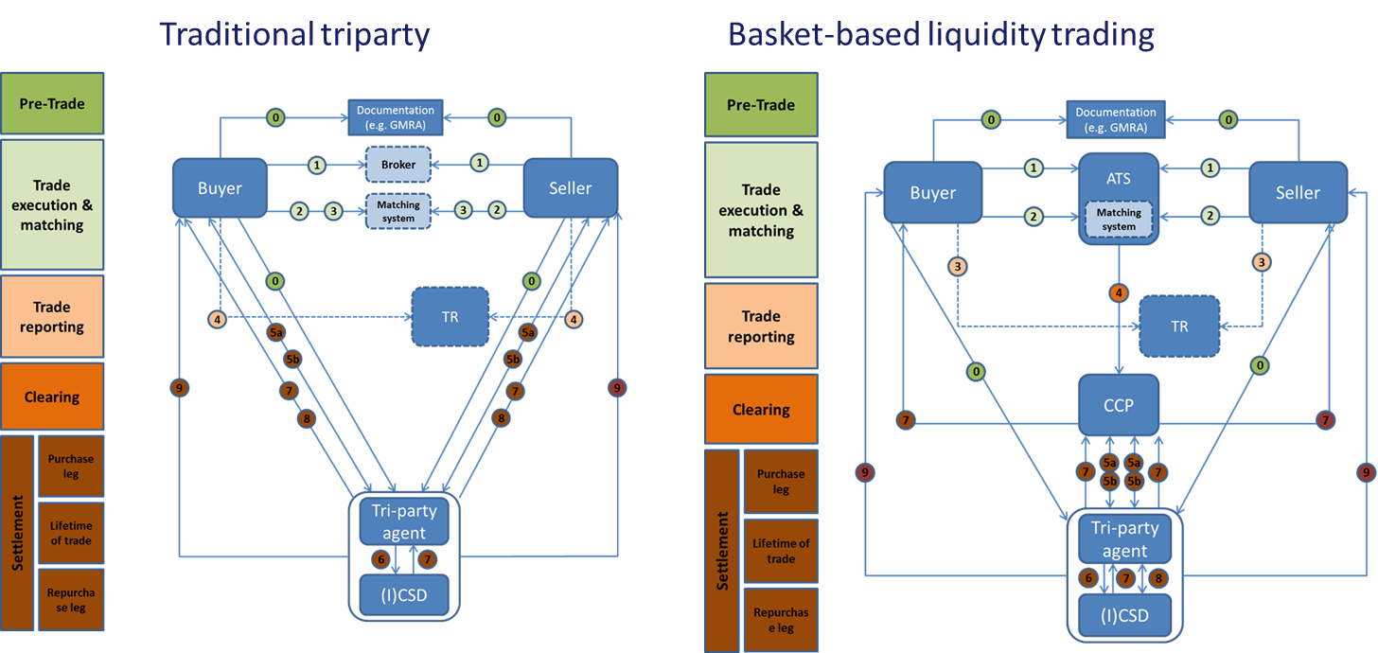

Examples of triparty messages (traditional triparty)
Messages (and their use) differ for instructions between the UCMS and the TPA both at the start of the trade (initiation) as during the life of the trade, including new instructions, modifications and cancellations. The messages also include feedback (status updates and reporting) from the TPA to the UCMS on collateral instructions.

Examples of messages from interaction between Eurosystem and TPAs (on cross-border basis)
 |  | CBF | CBL | EOC
Increase | Request | MT527 | MT527 | MT527
 | Confirmation | MT558 | MT558
Decrease | Request | MT527 | MT527 | MT527
 | Confirmation | MT558 | MT558
Settlement status | Settlement status | N/A | N/A | MT558
Revaluation | Intraday revaluation | N/A | MT569 | MT569
Cancellation | Cancellation | N/A | N/A | MT527
 | Confirmation | N/A | N/A | MT558
Closure | Closure | N/A | N/A | MT527
 | Confirmation | N/A | N/A | MT558
 | Statement | N/A | N/A | MT569
Compulsory Decrease | Revaluation | MT558 | MT569 | MT569
 | CA | MT558
Collateral suspension | Instruction | MT527 | N/A | N/A
 | Termination | MT527 | N/A | N/A
Unilateral removal | Unilateral removal | N/A | MT599 | N/A
 | Confirmation | N/A | MT599 | N/A
Reporting | End of day on flows | MT558 | MT536 | MT536
 | End of day on stocks | MT569 | MT569 | MT569
Technical receipt | After increase | MT558
 | After decrease | MT558

The ISO 15022 Triparty Collateral messages are also used outside of the Eurosystem, therefore the reverse engineering exercise will also take into account global requirements that could come from outside of Europe or from the commercial model that does not involve communication flows with the NCBs.

- Community of users and benefits:
- Users

The targeted community consists of the securities players that are involved in the Triparty Collateral Management exchanges: Triparty agents (typically Custodians and (I)CSDs and their clients (banks, NCBs, CCPs).
- Collateral Giver: the party that has an exposure and needs to provide collateral to cover its credit risk.
- Triparty Agent: the triparty service provider (referred to as “triparty agent” or TPA) responsible for the processing of instructions on behalf of both the collateral giver and the collateral taker
- Collateral Taker: the party that is exposed to its counterparty. Takes collateral to cover its exposure.

- Benefits/savings:
Foster an efficient use of collateral across financial markets and reduce operational barriers/problems in the messaging of collateral management activities and collateral mobility.
Triparty Collateral players that have not implemented ISO 15022 will be able to save a huge cost by not implementing ISO 15022 (specific syntax requiring specific expertise and programming skills).
For current ISO 15022 users, the strict reverse engineering approach (with mapping to ISO 15022 in mind) and the extensive coexistence support, will enable easy translation of their ISO 15022 messages in ISO 20022, while at the same time providing an eased migration to ISO 20022.
Take the opportunity to include additional functionalities in the ISO 20022 messages that are currently missing in ISO15022.
Creating ISO 20022 equivalent messages and maintaining this equivalence of the two standards during the coexistence period will limit the cost of migration for current users of ISO 15022 and the cost of coexistence. Indeed, this will allow for easy translation from one standard to the other, thereby allowing users of one standard to communicate with users of the other standard without need to support the two standards. Triparty agents will therefore be able to adopt ISO 20022 without having to maintain ISO 15022 until their last client migrates.

- Adoption scenario:
The usage of the ISO 20022 Triparty Collateral messages will be enforced in 2022 when the TPA’s will have to communicate with the ECMS exclusively in ISO 20022. ISO 20022 communication downstream will not be mandate and potential future migration will have to be agreed upon among the different industry players in due time.
The objective is to have good draft messages by the end of 2018. Messages development will be prioritised and therefore, should there be a need, the last draft messages could be delivered beginning Q1 2019 (to be agreed with the ECB and the industry players). The candidate ISO 20022 Triparty Collateral Management messages will be submitted to the RA in Q1 2019.
Representatives from key triparty agents and users will be invited to participate in the review of the messages developed and for that purpose a Business Validation Group will be composed to ensure involvement of the TPCM community throughout the development of the messages.
- Sponsors and adopters:
All the TPAs and any other financial institutions directly connected to ECMS (European Collateral Management System).

- Timing and development:
- the submitting organisations are planning to have the new candidate ISO 20022 business and message models developed and ready for submission to the RA Q1 2019;
- the submitting organisation will involve in the development the TPAs and their clients, the ECB and ECMS representatives and the service providers (Banco de España itself and Banque de France)
Vendors and non-European MIs will be included at the SubSEG level. Industry groups such as SMPG, PMPG, AMI-Pay, ESMA etc... will be kept informed on the progresses on a regular basis;
- potential creation of a standard API for a real-time Triparty Collateral and Exposure Report;

- Commitments of the submitting organisations:
SWIFT and Banco de España confirm that they can and will:
- undertake the development of the candidate ISO 20022 business and message models that it will submit to the RA for compliance review and evaluation. The submission must be compliant with the ISO 20022 Master Rules and include a draft Part 1 of the Message Definition Report (MDR) compliant with the template for MDR part 1 provided by the RA, the ISO 20022 Message Transport Mode (MTM) that the submitting organisation recommends to consider with the submitted message set, and, optionally, examples of valid and invalid instances of each candidate message. The submission may also include a Message User Guide (MUG) to complement the MDR and describe in further details how to use the different possibilities/options of the proposed candidate messages;
- address any queries related to the description of the models and messages as published by the RA on the ISO 20022 website.
SWIFT and Banco de España confirm that they will promptly inform the RA about any changes or more accurate information about the number of candidate messages and the timing of their submission to the RA. If the submitting organisations do not submit the candidate messages within the timing announced in section F and does not inform the RA beforehand, the business justification may lapse and require re-submission of a new business justification for approval by the RMG.
As the testing planning is not yet defined, the submitting organisations do not intend to organise any testing of the candidate messages once they have been reviewed and qualified by the RA and before their submission to the SEG(s) for approval.

SWIFT confirms it is committed to undertake the future messages maintenance.
SWIFT and Banco de España confirm their knowledge and acceptance of the ISO 20022 Intellectual Property Rights policy for contributing organisations, as follows:
“Organizations that contribute information to be incorporated into the ISO 20022 Repository shall keep any Intellectual Property Rights (IPR) they have on this information. A contributing organization warrants that it has sufficient rights on the contributed information to have it published in the ISO 20022 Repository through the ISO 20022 Registration Authority in accordance with the rules set in ISO 20022. To ascertain a widespread, public and uniform use of the ISO 20022 Repository information, the contributing organization grants third parties a non-exclusive, royalty-free licence to use the published information”.

- Contact persons:

Karine Taquet (Karine.taquet@swift.com )
Alexandre Hotat (alexandre.hotat@swift.com)
Oscar Lopez (oscar.lopez@bde.es)
Jose Manuel Celada ( jose.celada@bde.es)

- Comments from the RMG members and relevant SEG(s) or SubSEG(s) and disposition of comments by the submitting organisation:
This section will include the comments received from RMG members and the SEG(s) or SubSEG(s), if any, and the response given to each of these comments by the submitting organisation.

Technique to ‘re-capture’ the functionality of existing non ISO 20022 compliant message standards and feed it into the ISO 20022 models, thereby facilitating interoperability, co-existence and migration from existing messages to their ISO 20022 compliant equivalent.

