**Business Justification**

**for the development of new ISO 20022 financial repository items**

1. **Name of the request:**

System Notification Message

1. **Submitting organisation(s):**

Cross-Border Interbank Payment System (CIPS Co., Ltd.)

The Bund Square, 100 South Zhongshan Road,

Shanghai 200010,

China

1. **Scope of the new development:**

This submission is concerned with message related to the system notification of market infrastructure[1].

The following table outlines the financial instruments, business area and business process of this request.

|  |  |
| --- | --- |
| Financial Instruments | Administration |
| Business Area | Administration (admi) |
| Business Process | System Status Management |

In order to get the status notification of the system, we will submit the message below:

* CCP[2]SettlementNotification
* CCPSettlementNotification is sent from a payment market infrastructure to CCP to inform participants of the payment market infrastructure about CCP settlement status such as accepted, pending etc. After receiving a RequestforCCPSettlement[3] message from CCP, the payment market infrastructure replies this message to CCP. The market infrastructure will also send a CCPSettlement[4] message to participants with more details about CCP settlement information such as bank transaction code, business type, transfer amount etc.

The following diagram depicts the System Notification messages flows:

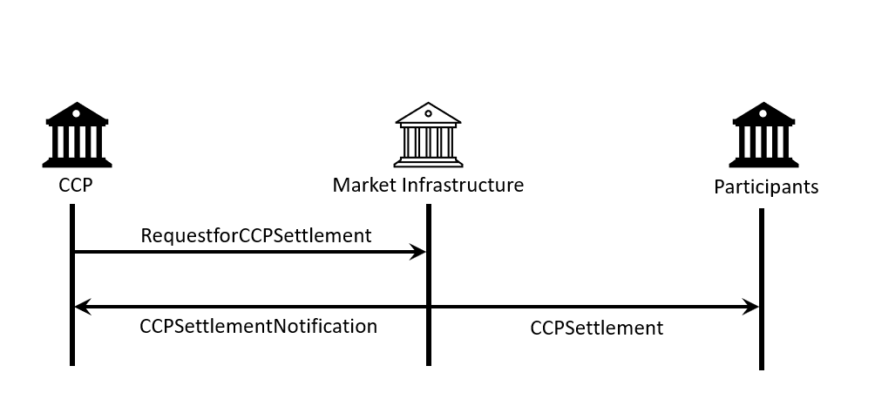

CIPS proposes that all SEGs and TSG should be assigned the evaluation of the candidate ISO 20022 messages.

CIPS supports optional use of BAH with all of the proposed messages.

CIPS intends to deploy the future messages in the ISO 20022 XML syntax.

1. **Purpose of the new development:**

Currently, there are no relevant ISO 20022 messages that could perform the task of CCP settlement notification. Developing the new message helps to fill the existing gap and enhances the implementation of ISO 20022 in a wide range of sectors, especially payment and settlement. Thus, CIPS decides to pursue standardized and transparent messages to better manage the system.

Generic benefits to the industry are highlighted as follows:

* Standardise business process of system notification
* Develop ISO 20022 messages which can be implemented by market participants more easily and at a lower cost
* Ensure efficiency, accuracy and consistency of system notification

1. **Community of users and benefits:**

These messages are designed to address the needs of CIPS to inform participants of system notice but are designed to be capable of adoption in similar contexts by other organisations as well.

Benefits and savings:

* Participants: use of a common nomenclature and terminology among participants by adopting a single standard will enhance the efficiency and transparency of system notice when processing message in the field of payment and settlement.
* Market infrastructure: mediates communication between participants by providing system notice. Standardized format and business information will improve the efficiency and security of system notification.

Adoption scenario:

System Notification Messages were designed and successfully put into operation in CIPS system since 2015. They are currently being used by all CIPS participants. After this ISO 20022 submission has been approved, participants will continue to use these messages and the commonality of these messages will be improved.

Volumes:

As of December 2020, CIPS has more than a thousand participants using CIPS system for payment and settlement. More than 10,000 trades had been executed and use CIPS system for message transmissions on a daily basis. It is expected to be continued growth as the expanding scale of cross-border business and the growing demand for cross-border transactions.

Sponsors and adopters:

The adoption is advocated and designated as mandatory by CIPS and it is already deployed to all participants.

1. **Timing and development:**

CIPS plans to complete the message development and registration process in Q3 2022.

The Business Justification will be submitted to the RA in October 2021 and seek approval by the RMG.

Candidate ISO 20022 message models and Message Definition Report will be developed and submitted to the RA in Q1 2022.

A pilot will be organized with CIPS participants to test the candidate message in May 2022. The purpose is to ensure that the documentation of the messages is accurate and consistent and to verify that the approved messages can be implemented with no adverse effects on communication infrastructures and applications.

Candidate ISO 20022 message models and Message Definition Report will be submitted for SEG(s) review and approval in June 2022.

We know that there is no other standard initiative involved in an effort to submit a Business Justification relating to system notification.

After the whole process is completed, this message can better serve participants and can be used in a more unified way.

1. **Commitments of the submitting organisation:**

CIPS confirms that it can and will:

* undertake the development of the candidate ISO 20022 business and message models that it will submit to the RA for compliance review and evaluation. The submission must be compliant with the [ISO 20022 Master Rules](http://www.iso20022.org/documents/general/ISO20022_MasterRules.ZIP) and include a draft Part 1 of the Message Definition Report (MDR) compliant with the [template for MDR part 1](http://www.iso20022.org/documents/general/ISO20022_MasterRules.ZIP) provided by the RA, the [ISO 20022 Message Transport Mode](http://www.iso20022.org/documents/general/MessageTransportModes.xls) (MTM) that CIPS recommends to consider with the submitted message set, and examples of valid instances of each candidate message;
* address any queries related to the description of the models and messages as published by the RA on the ISO 20022 website.

CIPS confirms that it will promptly inform the RA about any changes or more accurate information about the number of candidate messages and the timing of its submission to the RA. If CIPS does not submit the candidate messages within the timing announced in section F and does not inform the RA beforehand, the business justification may lapse and require re-submission of a new business justification for approval by the RMG.

CIPS confirms that it intends to organize any testing of the candidate messages once they have been reviewed and qualified by the RA and before its submission to the SEG(s) for approval. The testing is expected to complete in May 2022 and the candidate message will be re-submitted to the RA for SEG(s) approval. CIPS confirms that it will promptly inform the RA about any changes or more accurate information about the timing of this re-submission to the RA. If CIPS does not re-submit the candidate messages as announced and does not inform the RA beforehand, the business justification may lapse and require re-submission of a new business justification for approval by the RMG.

CIPS confirms that it is committed to undertake the future message maintenance.

CIPS confirms its knowledge and acceptance of the ISO 20022 Intellectual Property Rights policy for contributing organisations, as follows.

*“Organizations that contribute information to be incorporated into the ISO 20022 Repository shall keep any Intellectual Property Rights (IPR) they have on this information. A contributing organization warrants that it has sufficient rights on the contributed information to have it published in the ISO 20022 Repository through the ISO 20022 Registration Authority in accordance with the rules set in ISO 20022. To ascertain a widespread, public and uniform use of the ISO 20022 Repository information, the contributing organization grants third parties a non-exclusive, royalty-free license to use the published information”.*

1. **Contact persons:**

* JI Chenjue jicj@cips.com.cn

Staff- Standardization Department, CIPS

* Weiwei Shen sww@cips.com.cn +86 21 63120212

Assistant General Manager - Standardization Department, CIPS

1. **Comments from the RMG members and relevant SEG(s) or SubSEG(s) and disposition of comments by the submitting organisation:**

**Round 1 Review**

**France:**

* The Securities SEG should be involved in the review of the message definitions (for example for the CIPS System Status Notification review) to make sure that the requested additional messages are not yet covered by existing ISO 20022 message definitions.
* Response by CIPS
* We agree that proposed messages should be reviewed by all SEGs and TSG.

**Norway:**

* Encryption of files (and handling of them) is relevant not only for payment/finance, but also for all other types of files containing sensitive information that needs to be encrypted. Hence we wonder if the message type should be camt, and if Payment SEG is the correct entity to evaluate.
* Has CIPS explored weather there are other existing, relevant standards that could be used for this purpose? It is not clear from the document weather CIPS has done so or not apart from that there is no ISO 20022 message type that can be used.
* Response by CIPS
* We agree that the message type for BJ 194 could be revised to Administration (admi).
* We have studied the existing standards and regrettably they cannot serve the purpose performed by BJ 193 and BJ 194.

**Cross SEG Harmonisation:**

* The technical nature of the message definitions could apply for any ISO 20022 business area. The Payments SEG can perform the review but it probably should be run by the other SEG groups for information as well.
* Response by CIPS
* Given the technical nature of the messages, we agree to review by TSG.

**Payments SEG:**

* The SEG who will review the candidate messages submitted by CIPS will need some support from the TSG given that these are technical messages.
* Response by CIPS
* We agree that proposed messages should be reviewed by all SEGs and TSG.

**Switzerland:**

* Provided in the document below



* Response by CIPS
* 1. We agree with adding definitions and roles regarding CCP and market infrastructure. As for BJ 186 of the Bank of England, BJ 193 is not an adaption of the former. BJ 193 contains CCPSettlementNotification while BJ 186 focuses on RequestforCCPSettlement.
* 2. In reference to a number of existing ISO 20022 messages, the message names used in BJ 193 differ from those of the ISO 20022 standard. This is because usage scenarios are intended to be market practices based on the existing ISO 20022 messages. The messages are only mentioned in the BJ to help outline the business process and development of the messages is not requested by the BJ.
* 3. Optional BAH could be supported.
* We propose that some elements of CIPS BAH be duplicated in the ISO 20022 messages. These elements should include Organization Identification, Business Message Identifier, Creation Date, and Financial Institution Identification.
* 4. The messages are decrypted and analyzed by the market infrastructure before store-and-forward, and contain elements of business information. In other words, these business-oriented messages cannot be realized through technical protocols.
* **Round 2 Review**
* **Further Clarifications for SASFS**
* **Clarifications related to BJ 193:**
* 1.  In scenario 1, the role of MI is exclusively a payments market infrastructure.
* SASFS> We would recommend to reflect this fact in the updated version of the BJs. This should prove beneficial for the other BJ reviewers (RMG members, SEGs, etc) in order to understand the proposed business process and message flows.
* **CIPS> Yes, we have updated the BJs.**
* 2. We have studied functions and components of relevant pacs and camt messages. These existing messages share the intended functions of Scenario 2-7. We will remove these messages from the BJ, and if different elements are required, we will submit a request of change later on.
* SASFS> We understand that you will provide an updated version of the BJ to reflect this.
* **CIPS> Yes, we attach the updated BJ in the email.**

1. Market infrastructure refers to a system administered by a public organization or other public instrumentality, or a private and regulated association or entity, that provides services to the financial industry for trading, clearing and settlement, matching of financial transactions, and depository functions.
2. CCP refers to central counterparty in the securities area. A CCP reduces systemic risk and enhances financial stability by standing between the two counterparties to a securities trade.
3. RequestforCCPSettlement is sent from central counterparty to a market infrastructure after a deal is made between two participants of the market infrastructure. The message identifier of it is pacs.009.001.06. The message is mentioned to help outline the business process and development of the message is not requested by the BJ.
4. CCPSettlement is sent from a market infrastructure to participants with settlement information such as bank transaction, transfer amount etc. The message identifier of it is camt.054.001.06. The message is mentioned to help outline the business process and development of the message is not requested by the BJ.