Change Request
for the update of ISO 20022 financial repository items
- Origin of the request:
A.1 Submitter:
The Mojaloop Foundation
A.2 Contact person:
Michael Richards. Michael.Richards@infitx.com, +44 7785 360009
A.3 Sponsors:
1) Africanenda
2) Comesa Business Council
Contact: Dr. Jonathan Pinifolo, jpinifolo@comesabusinesscouncil.org
- Related messages:
Pacs.002.001 - FIToFIPaymentStatusReport
New message to be defined sealing the agreement of terms between the parties.

- Description of the change request:
We want to add an element to the data structure which describes a payment transaction. This element will contain a signature which other parties to the payment can use to verify that the beneficiary’s FI has warranted that the transaction has completed on their books, and will be used if the payment execution request has used the ILP v4 method of cryptographic locking See CR 1357 and CR 1358).
This element is optional and non-repetitive. It will be in the form of an encoded string, and is an instance of the existing ISO 20022 Exact32HexBinaryText type described in CR 1358. We propose the name ExecutionConfirmation for the element.
We propose that it should be added to the TxInfAndSts element of the FIToFIPaymentStatusReport data structure. This will result in new issues of the FIToFIPaymentStatusReport and PaymentTransaction elements.
Current structure of the PaymentTransaction element:

Or | MessageElement<XML Tag> | Mult. | Type | Constr. No. | Page
 | StatusIdentification <StsId> | [0..1] | Text |  | 32
 | OriginalGroupInformation <OrgnlGrpInf> | [0..1] | ± |  | 32
 | OriginalInstructionIdentification <OrgnlInstrId> | [0..1] | Text |  | 32
 | OriginalEndToEndIdentification <OrgnlEndToEndId> | [0..1] | Text |  | 32
 | OriginalTransactionIdentification <OrgnlTxId> | [0..1] | Text |  | 33
 | OriginalUETR <OrgnlUETR> | [0..1] | IdentifierSet |  | 33
 | TransactionStatus <TxSts> | [0..1] | CodeSet |  | 33
 | StatusReasonInformation <StsRsnInf> | [0..*] |  | C26 | 33
 | ChargesInformation <ChrgsInf> | [0..*] | ± |  | 35
 | AcceptanceDateTime <AccptncDtTm> | [0..1] | DateTime |  | 35
 | EffectiveInterbankSettlementDate <FctvIntrBkSttlmDt> | [0..1] | ± |  | 35
 | AccountServicerReference <AcctSvcrRef> | [0..1] | Text |  | 35
 | ClearingSystemReference <ClrSysRef> | [0..1] | Text |  | 35
 | InstructingAgent <InstgAgt> | [0..1] | ± |  | 36
 | InstructedAgent <InstdAgt> | [0..1] | ± |  | 36
 | OriginalTransactionReference <OrgnlTxRef> | [0..1] |  |  | 36

Proposed structure of the PaymentTransaction element:

Or | MessageElement<XML Tag> | Mult. | Type | Constr. No. | Page
 | StatusIdentification <StsId> | [0..1] | Text |  | 32
 | OriginalGroupInformation <OrgnlGrpInf> | [0..1] | ± |  | 32
 | OriginalInstructionIdentification <OrgnlInstrId> | [0..1] | Text |  | 32
 | OriginalEndToEndIdentification <OrgnlEndToEndId> | [0..1] | Text |  | 32
 | OriginalTransactionIdentification <OrgnlTxId> | [0..1] | Text |  | 33
 | OriginalUETR <OrgnlUETR> | [0..1] | IdentifierSet |  | 33
 | TransactionStatus <TxSts> | [0..1] | CodeSet |  | 33
 | StatusReasonInformation <StsRsnInf> | [0..*] |  | C26 | 33
 | ChargesInformation <ChrgsInf> | [0..*] | ± |  | 35
 | AcceptanceDateTime <AccptncDtTm> | [0..1] | DateTime |  | 35
 | EffectiveInterbankSettlementDate <FctvIntrBkSttlmDt> | [0..1] | ± |  | 35
 | AccountServicerReference <AcctSvcrRef> | [0..1] | Text |  | 35
 | ClearingSystemReference <ClrSysRef> | [0..1] | Text |  | 35
 | InstructingAgent <InstgAgt> | [0..1] | ± |  | 36
 | InstructedAgent <InstdAgt> | [0..1] | ± |  | 36
 | OriginalTransactionReference <OrgnlTxRef> | [0..1] |  |  | 36
 | ExecutionConfirmation <ExctnCnfrmtn> | [0..1] | Exact32HexBinaryText

We propose the following MDR description of the change:
Presence: [0..1]
Definition: when the FI which assumes credit risk as a result of completing the payment has satisfied itself that the payment which it is being asked to execute is a payment to whose terms it has agreed, and when it has committed to crediting the beneficiary with the payment, it responds to the other parties to the payment with a cryptographic key. The other parties to the payment can subsequently use this key to satisfy themselves that the credit party has warranted that they have executed the payment.

Usage: Where it is important to reduce the cost of failed payments, an institution or a payments scheme may elect to require that the terms of a payment are agreed in advance between the parties. Where this is the case, they may further wish to confirm this by issuing to the other parties a means which the other parties can use to assert, when they request execution of the payment, that the execution is based on a set of terms which have been agreed by the creditor institution and which have not been varied by any other party. When the creditor party subsequently commits the payment, it may return a cryptographic key to the other parties to the payment. Those parties can use the verifiable relationship between the key and the original lock, together with a non-repudiation signature, to implement a two-factor verification that the commitment matches the original lock which was applied to the terms of the payment, and that it was in fact issued by the party who originally sealed the terms of the payment.

“Payment” here refers to an individual credit transfer. The standard does not mandate the inclusion of this information for every payment in an overall FI to FI payment instruction; nor does it prescribe the form that this verification should take. These are matters for individual implementations.
Datatype: " Exact32HexBinaryText"

- Purpose of the change:
This change is designed to support a radical reduction in the costs associated with processing payments by removing the majority of the costs incurred by financial institutions in remediating failed payments.
A survey based on material collected in 2021 by LexisNexis concluded that the average annual cost of failed payments (defined as payments that were rejected by a participant in the payment chain, and therefore excluding failures due to communications breakdowns) was $360k for banks, $220k for non-bank financial institutions, and $200k for corporates. The causes of these failures were broken down as shown below:

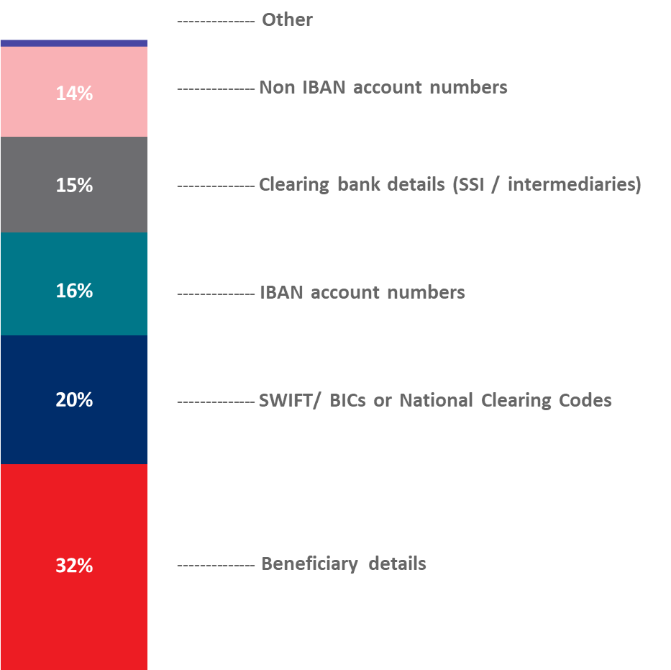
It appears clear from this analysis that most payment failures could be intercepted before a payment request is made.
A successful IIPS system must be capable of processing large numbers of low-value transfers (their target average value is 1USD) at a cost which makes the system viable. This requirement means that an IIPS system needs to avoid failures of the kind described above if at all possible, since failures require time to be spent across all parties in the dispute.
A key technique for achieving this aim is that IIPS systems require the parties to agree on the terms of the payment before any funds are committed. In order to meet this requirement, it is also necessary for the party who confirms the payment (that is, the creditor party) to be able to verify that it is in fact being asked to execute a payment whose terms it has agreed, and for other parties to the payment to be able to verify that the creditor party has warranted that it has in fact cleared the funds to its beneficiary, so that all parties will agree on the status of the payment.
In order to implement this technique, it must be possible to associate with the credit transfer request sufficient information to allow institutions which process the credit transfer request to verify, first, that the request has been reliably approved by the credit party and, second, that the terms of the credit transfer are in fact those which were approved and have not been varied in the interim. This information is associated with the credit transfer and not with the overall payment request. It would be perfectly legitimate for sets of terms to be agreed individually, or even out of band, and for them then to be bundled together in a single payment request.
When the creditor party to the payment approves the payment execution request, it will provide evidence which other parties to the payment can use to check that the cryptographic lock which they presented to the creditor institution was approved by the payer institution, and that it was the payer institution that approved it.
This proposal does not specify the type of information which a scheme will mandate in order to achieve these objectives, nor the procedures that IIPS systems will use to verify the legitimacy of the credit transfer request. We envisage that these will be matters for the Market Practice Document for individual implementations.
- Urgency of the request:
It is proposed to include this change request in the next regular maintenance cycle.
- Business examples:
The sequence diagram below shows an example of how the debtor party to a payment could attach to the payment execution request the cryptographic lock that it received from the creditor party when the creditor party approved the terms of the transfer. It then shows how the creditor party could use the cryptographic lock to verify that the proposed transfer matches the terms which it agreed to, and how the confirmation could be used by the other parties to the payment to confirm that the creditor party’s approval is an approval of the payment whose cryptographic lock was originally passed to the creditor party.
These features are shown in the following diagram:
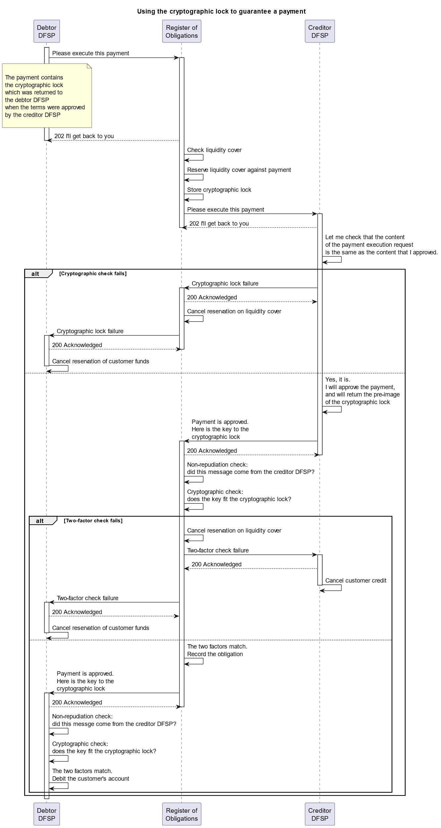
- SEG/TSG recommendation:
This section is not to be taken care of by the submitter of the change request. It will be completed in due time by the SEG(s) in charge of the related ISO 20022 messages or the TSG for changes related to the BAH.

Consider |  | X | Timing
 |  |  | - Next yearly cycle: 2024/2025  (the change will be considered for implementation in the yearly maintenance cycle which starts in 2024 and completes with the publication of new message versions in the spring of 2025) |  | X
- At the occasion of the next maintenance of the messages
(the change will be considered for implementation, but does not justify maintenance of the messages in its own right – will be pending until more critical change requests are received for the messages)
- Urgent unscheduled
(the change justifies an urgent implementation outside of the normal yearly cycle)
 |  |  | - Other timing:
Comments: CR will be reviewed as part of the 2024/2025 maintenance cycle.

Reject
Reason for rejection:

True-Cost-of-Failed-Payments-Global-Report-2021-1_compressed.pdf (trustyoursupplier.com)

