Maintenance Change Request
for fast track maintenance of existing message definitions

- Submitting organization(s):
European Securities and Markets Authority (ESMA)
201-203 rue de Bercy
75012 Paris
France

- Related messages:
auth.033.001.02 (FinancialInstrumentReportingNonEquityTransparencyDataReportV02)

- Purpose of the change:
The European Commission Delegated Regulation (EU) 2017/587 (RTS 1) and Commission Delegated Regulation (EU) 2017/583 (RTS 2) further specify the MiFIR pre-trade and post-trade transparency requirements for equity, equity-like and non-equity instruments, respectively.
In March 2022 ESMA submitted to the European Commission (EC) a Final Report including its final proposed amendments on RTS 1 and 2 which were endorsed and published in the Official Journal on 16 May 2023.
Based on the new business requirements in RTS2 ESMA needs to perform two minor changes in the non-equity transparency reference data XML schema. Both changes are related to the extension of the code sets by externalising them to ensure easier maintenance of the codes which may be updated on a frequent basis. The purpose of updates is to enable the reporting entities to provide the necessary information to ESMA and to align with the changes in the regulation:
- Externalise the code set of the Underlying Instrument Asset Class Sub-type (/Document/FinInstrmRptgNonEqtyTrnsprncyDataRpt/NonEqtyTrnsprncyData/UndrlygInstrmAsstClss) element and add further element to the master code set (‘OCTN’ – Other C10);
- Externalise the code set of the Emission Allowance Sub-type element (/Document/FinInstrmRptgNonEqtyTrnsprncyDataRpt/NonEqtyTrnsprncyData/EmssnAllwncTp) in order to use other elements of the existing master code set (e.g. ‘OTHR’ - other);
ESMA proposes the code set externalization instead of the new code value addition to the existing list of codes in the message as these lists of codes are subject to future changes.
In addition to the above a full review of the Markets in Financial Instruments Regulation (MiFIR) is expected in 2024, which may result in further changes to the transparency reporting messages. Therefore, ESMA aims to keep the current modification of the non-equity transparency reference data report to a minimum level. Moreover, ESMA primarily aims to approve the externalization of the relevant code sets, and may keep the V03 base message in form of draft until further updates are performed in 2024 to minimize the need of maintaining multiple base messages in the ISO 20022 repository.

- Urgency of the request:
There is no structural modification in the proposed solution, the changes in the messages are limited to updates of the code list of the two fields mentioned above by externalizing the relevant code sets.
As these improvements are minor and will facilitate proper reporting and improve data quality, ESMA aims at including changes in the next major maintenance release cycle of its FITRS system (supporting the MiFIR transparency calculations) , for which testing would start in Q1 2024 and go-live by the end of May 2024.
To accommodate for sufficient lead time for the reporting entities to adapt to the changes, the updated XML Schema will need to be published in by the end of November 2023.

- Commitments of the submitting organization:
The ESMA FITRS project team confirms that it plans to develop a new version of the impacted message and system in accordance with the changes proposed in this document.

- Contact persons:

Krisztina Miklossy – krisztina.miklossy@esma.europa.eu
Michal Zubrycki – michal.Zubrycki-ext@esma.europa.eu

Change number #1

- Related messages:
auth.033.001.02 FinancialInstrumentReportingNonEquityTransparencyData Report

- Description of the change and type of impact:
For the purpose of regulatory reporting of financial instrument transparency reference data (Regulatory Technical Standard 2), the reporting entities needs to be enabled to report an additional specified asset class type in the ‘Underlying Instrument Asset Class’ field (XML path: /Document/FinInstrmRptgNonEqtyTrnsprncyDataRpt/NonEqtyTrnsprncyData/
UndrlygInstrmAsstClss).
In the current version the following asset types are presented in the internal code-list:
- Commodity [COMM]
- Credit [CRDT]
- Currency [CURR]
- Emmission Allowance [EMAL]
- Equity [EQUI]
- Interest Rate [INTR]
The new asset type that needs to be enabled for the transparency reporting is ‘OCTN’ (other C10), but additional codes can be also expected in the future. Therefore the list should not be fixed on the base message level, but instead could be maintained via an externalised code list.
The Underlying Instrument Asset Class field is now an optional field [0,1] populated with ProductType5Code, restricted from the ProductTypeV2Code list, which specifies the type of product or financial instruments with a 4-characters length code.

- Proposed implementation:
ESMA proposes the following solution:
- Creation of ExternalProductTypeCode master code set.
- The master code set will be extended with the new product type code: ‘OCTN’ (other C10).
- The currently used ProductType5Code in the Underlying Instrument Asset Class’ field (/Document/FinInstrmRptgNonEqtyTrnsprncyDataRpt/NonEqtyTrnsprncyData/
UndrlygInstrmAsstClss) will be replaced by the new code set ExternalProductType1Code (based on the above master code set). The underlying schema element remains ‘optional’ [0,1].

The following elements will be presented in the master code set and the externalised code set including the newly added code (Other C10 - OTCN):

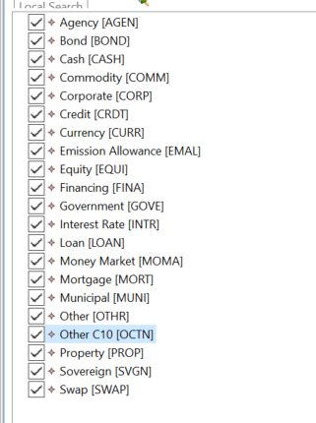

Approved message | Proposed change
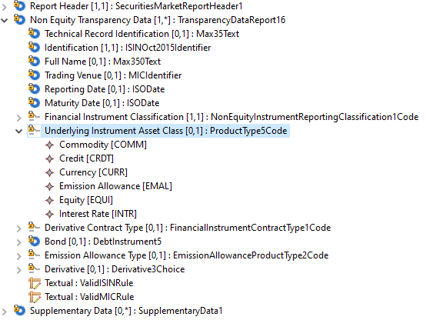 | 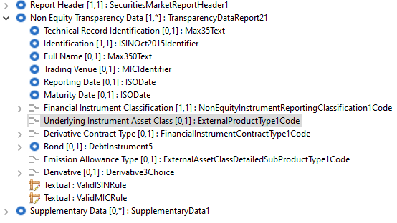

- Decision of the SEG(s):
This section is not to be taken care of by the submitting organization. It will be completed in due time by the SEG(s) in charge of the related ISO 20022 message definitions.

Change
 | approved | X
 | rejected
Comments:
Following the request from the SEG the following implementation and codes have been agreed:

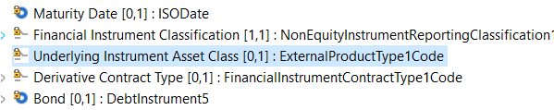
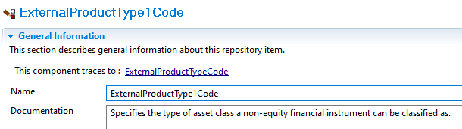
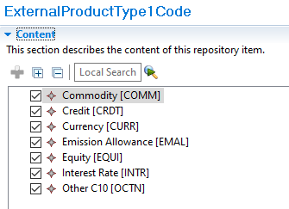
Timing
 | - Fast track maintenance  (the change justifies an urgent implementation using the fast track maintenance process) |  | X
- At the occasion of the next maintenance of the messages
(the change will be considered for implementation, but does not justify an urgent implementation – will be pending until the next [yearly] maintenance of the messages)

Change number #2

- Related messages:
auth.033.001.02 FinancialInstrumentReportingNonEquityTransparencyData Report

- Description of the change and type of impact:
For the purpose of regulatory reporting of financial instrument transparency reference data (Regulatory Technical Standard 2), the reporting entities needs to be enabled to report an additional specified emission allowance instruments sub-type in the ‘Emission Allowance Type’ field (XML path: /Document/FinInstrmRptgNonEqtyTrnsprncyDataRpt/ NonEqtyTrnsprncyData/EmssnAllwncTp).
In the current version the following emission allowance types are presented in the internal derived code-list (EmissionAllowanceProductType2Code):
- CER [CERE] – Certified Emission Reduction
- ERU [ERUE] – Emission Reduction Units
- EUA [EUAE] – European Union Allowance
- EUAA [EUAA] – European Union Aviation Allowance
The new type that needs to be enabled for the transparency reporting is ‘OTHR’ (other) which is already part of the existing master code set, but to facilitate future potential (and more frequent) changes when the code list needs to be amended, the list should be maintained via an externalised code list.
The Emission Allowance Type field is now an optional field [0,1] populated with EmissionAllowanceProductType2Code, restricted from the AssetClassDetailedSubProductTypeCode list, which specifies the detailed sub product types allowed for commodity derivatives with a 4-characters length code.

- Proposed implementation:
ESMA proposes the following solution:
- Creation of ExternalAssetClassDetailedSubProductTypeCode master code set.
- The currently used EmissionAllowanceProductType2Code in the ‘Emission Allowance Type’ field (/Document/FinInstrmRptgNonEqtyTrnsprncyDataRpt/ NonEqtyTrnsprncyData/EmssnAllwncTp) will be replaced by the code set ExternalAssetClassDetailedSubProductType1Code (from the new master code set). The schema element remains ‘optional’ [0,1].

The master code set and the externalised code set will include the following elements:

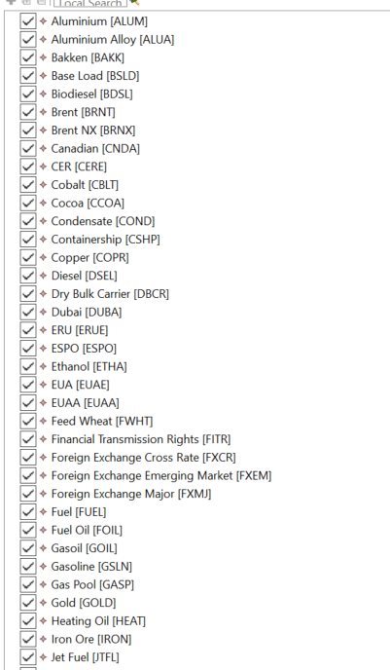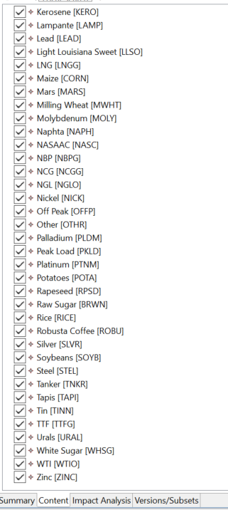

Approved message | Proposed change
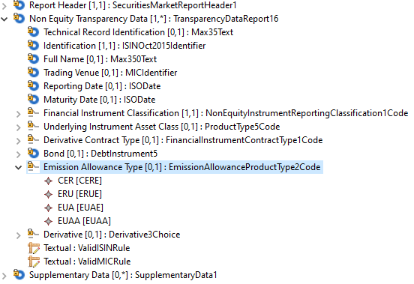 |  | 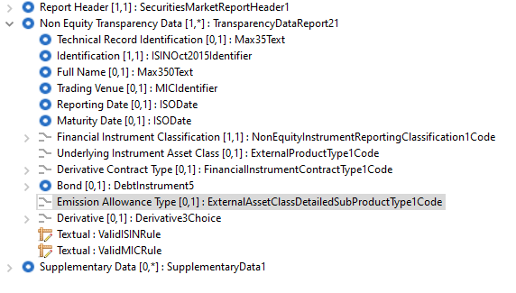

- Decision of the SEG(s):
This section is not to be taken care of by the submitting organization. It will be completed in due time by the SEG(s) in charge of the related ISO 20022 message definitions.

Change
 | approved | X
 | rejected
Comments:

Following the request of the SEG, below is the final approved version and codes:
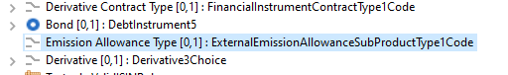
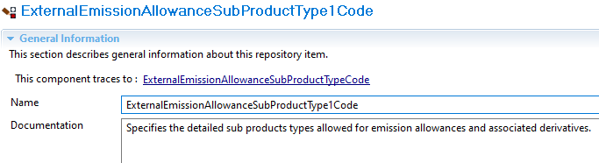
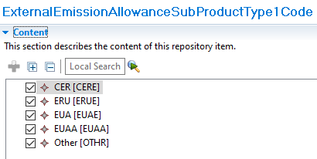

Timing
 | - Fast track maintenance  (the change justifies an urgent implementation using the fast track maintenance process) |  | X
- At the occasion of the next maintenance of the messages
(the change will be considered for implementation, but does not justify an urgent implementation – will be pending until the next [yearly] maintenance of the messages)

Commission Delegated Regulation (EU) 2017/583 of 14 July 2016 supplementing Regulation (EU) No 600/2014 of the European Parliament and of the Council on markets in financial instruments with regard to regulatory technical standards on transparency requirements for trading venues and investment firms in respect of bonds, structured finance products, emission allowances and derivatives.

