Change Request
for the update of ISO 20022 financial repository items
Note: the purpose of this document is to give guidelines to parties who want to introduce a request to change an existing ISO 20022 message(s), or update other items of the ISO 20022 financial repository. Such change requests are subject to the approval of the ISO 20022 Standards Evaluation Group(s) in charge of the related message/item or to the approval of the Technical Support Group (TSG), if the requested change relates to the Business Application Header (BAH). Please consult the iso20022.org website for additional details on the maintenance process. Change requests are to be sent to iso20022ra@iso20022.org. All change requests conforming to this template received by June 1st will be considered for development in the following yearly ISO 20022 maintenance cycle which completes with publication of new message versions in April/May of the following year.
- Origin of the request:
A.1 Submitter: ISITC

A.2 Contact person: Jason Brasile jbrasile@statestreet.com

A.3 Sponsors: ISITC
ISITC represents just under 100 organisations from the buy-side, sell-side, global custodian, vendor and utility communities. This change request has broad support from the Investment Management and Global Custodian community.
- Related messages:
Notification to Receive message set:
- camt.057.001.07 - NotificationToReceiveV07
Payments Clearing and Settlement message set:
- pacs.009.001.10 - FinancialInstitutionCreditTransferV10
- Description of the change request:
StructuredRemittanceInformation data type should be updated to include optional Allocation element.
Usage of Allocation element must always be bilaterally agreed between sender and receiver.
The element must be repeatable.
The element must contain sub-elements Account, Amount, Purpose and Reference, these should not be repeatable and are mandatory.
An additional sub-element Related Reference should also be present, this is optional and repeatable. It should use data type References1Choice to align with the sese.023 message definition.

Once updated the StructuredRemittanceInformation data type should be added to the pacs.009 within the Remittance Information element.

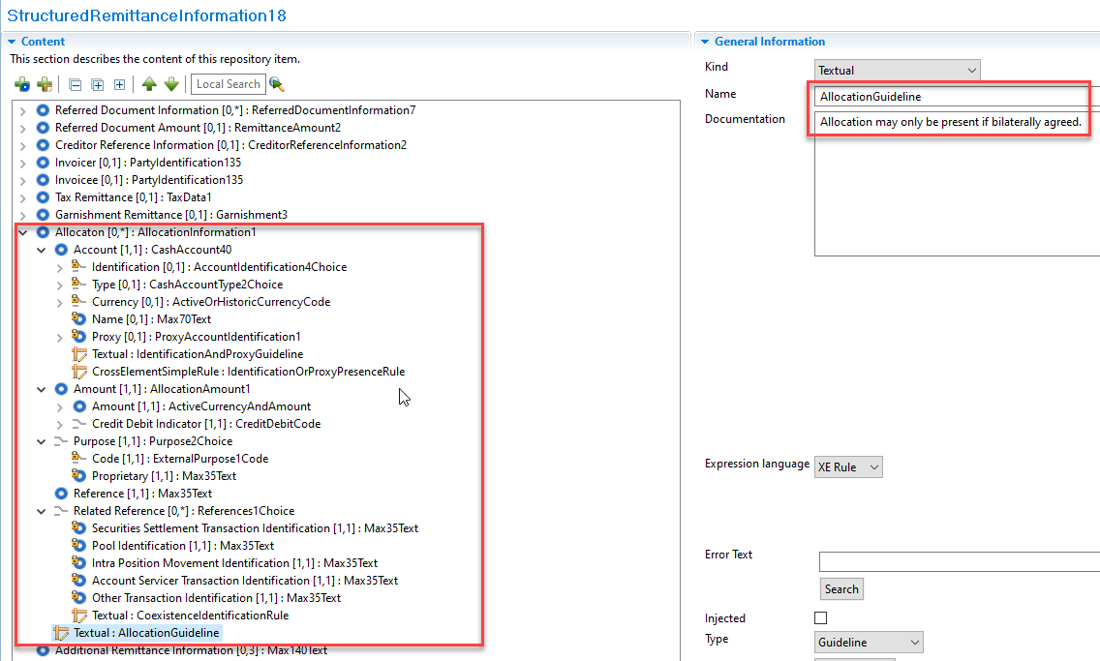

- Purpose of the change:
Investment Managers instruct their account servicers to make a net payment (pacs.009) / expect a net receipt (camt.057) from/to a single custody account. However, Investment Managers also send the related fund accounting/breakdown information in a separate instruction, typically a proprietary format such as fax or email.
The CR aims to introduce a standard format and syntax for providing breakdown information and/or additional accounting detail related to a net payment or net receipt of funds, allowing both the Investment Manager and Account Servicer to automate the processing of the breakdown.
The preference of the Securities Industry is to include this information within the pacs.009/camt.057 as opposed to developing a separate message.
There is no requirement to update the pacs.002, camt.056 or camt.058 in relation to this change. We expect that when a pacs.009 or a camt.057 is cancelled the account servicer automatically cancels all accounting associated with it. Furthermore for reviewing the breakdowns, we expect that impacted Securities account owners will leverage cash statement messages on a next day basis.
We believe this will lead to significant savings for the Securities Industry in terms of the reduction/elimination of manual processing, as well as the reduction/elimination of fails and interest claims. A precise estimate of said savings is not feasible. However, we believe that closing this gap in the coverage of message standards significantly enhances the value proposition for migration to ISO 20022 for the Securities Industry.
- Urgency of the request:
2024 publication
- Business examples:
Breakdown information currently transported via manually over spreadsheet/email –
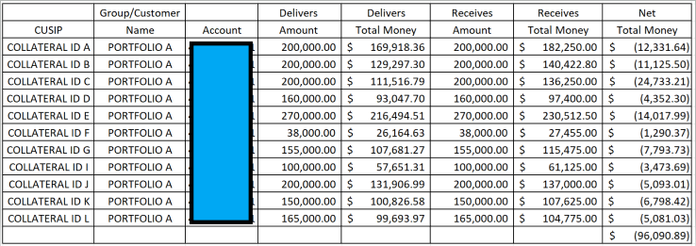
SEG/TSG recommendation:
This section is not to be taken care of by the submitter of the change request. It will be completed in due time by the SEG(s) in charge of the related ISO 20022 messages or the TSG for changes related to the BAH.

Consider |  | X | Timing
 |  |  | - Next yearly cycle: 2023/2024  (the change will be considered for implementation in the yearly maintenance cycle which starts in 2022 and completes with the publication of new message versions in the spring of 2023) |  | X
- At the occasion of the next maintenance of the messages
(the change will be considered for implementation, but does not justify maintenance of the messages in its own right – will be pending until more critical change requests are received for the messages)
- Urgent unscheduled
(the change justifies an urgent implementation outside of the normal yearly cycle)
 |  |  | - Other timing:
Comments:

Reject
Reason for rejection:

