Maintenance Change Request

Note: the purpose of this document is to give guidelines to submitting organisations that will develop a new version of existing ISO 20022 messages based on change requests screened by the Standards Evaluation Group(s). Such development is subject to the approval of a Maintenance Change Request which must include a detailed description of the impact of each change on the related messages. The Maintenance Change Request must start with a general chapter covering topics related to the whole maintenance effort and a specific chapter for each change request, as described below. Please consult the iso20022.org website for additional details on the maintenance process.

- Name of the request:
Shareholder Identification Disclosure Messages Maintenance for year 2023/2024
- Submitting organization(s):
Swift, SMPG
- Related messages:
Under this project, the following ISO 20022 Shareholders Identification messages highlighted in blue below will be maintained in the context of the Shareholder Identification Disclosure messages maintenance for year 2023/2024.

 | Message Name | Abbreviated Name | Identifier
1 | ShareholdersIdentificationDisclosureRequestV04 | SIDR | seev.045.001.04
2 | ShareholdersIdentifiocationDisclosureRequest CancellationAdviceV01 | SIDC | seev.046.001.01
3 | ShareholdersIdentificationDisclosureResponseV02 | SIRE | seev.047.001.02
4 | ShareholderIdentificationDisclosureResponse  CancellationAdviceV01 | SIRC | seev.048.001.01
5 | ShareholdersIdentificationDisclosureRequestV04 | SIRS | seev.049.001.01
6 | SecuritiesMessageRejectionV03 |  | semt.001.001.03
- Commitments of the submitting organization:
Swift and SMPG confirm that it can and will:
- undertake the development of the new version of the candidate ISO 20022 message models that it will submit to the RA for compliance review and evaluation by September 2023.
- provide a new version of part 1 of the Message Definition Report (MDR) and new examples of valid message instances of each message by October 2023 at the latest.
- address any queries related to the description of the new models and messages as published by the RA on the ISO 20022 website.
Swift confirms that it intends to organize the actual implementation of the new version of the messages on its SwiftNet network once the related documentation has been published by the RA.

The submitting organisations confirm their knowledge and acceptance of the ISO 20022 Intellectual Property Rights policy for contributing organisations, as follows.
“Organisations that contribute information to be incorporated into the ISO 20022 Repository shall keep any Intellectual Property Rights (IPR) they have on this information. A contributing organisation warrants that it has sufficient rights on the contributed information to have it published in the ISO 20022 Repository through the ISO 20022 Registration Authority in accordance with the rules set in ISO 20022. To ascertain a widespread, public and uniform use of the ISO 20022 Repository information, the contributing organisation grants third parties a non-exclusive, royalty-free license to use the published information”.

- Contact persons:
Christine Strandberg – christine.strandberg@seb.se – phone: +46 8 763 6074
Mari Fumagalli – mariangela.fumagalli@bnpparibas.com – phone: +44 207 595 4988
Jacques Littré – jacques.littre@Swift.com – phone: +32 2 655 43 35
ISO 20022 General Meeting Messages Maintenance 2023/2024

Table of Contents

1 CR 1296 Amend Usufructuary Definition in Disclosure Response 4
2 CR 1287 Add new Format for Activities Classification 7
3 CR 1314 Add new ShareholdingType code for Legally Non Disclosable Type 10

CR 1296 Amend Usufructuary Definition in Disclosure Response
- Origin of the request:
A.1 Submitter: SMPG CA WG
A.2 Contact person:
Christine Strandberg: christine.strandberg@seb.se
Mariangela Fumagalli: mariangela.fumagalli@bnpparibas.com
Jacques Littré: Jacques.littre@Swift.com
A.3 Sponsors:
SMPG CA WG members
- Related messages:
seev.047.001.02 - ShareholdersIdentificationDisclosureResponseV02

- Description of the change request:
In the data type code AccountOwnershipType5Code, change the current definition of the code value USUF (Usufructuary) as follows:
Current definition: “The person is…”
New definition: “Person having the temporary right to use and derive income or benefit from someone else's property.”
This data type is used to the message element “Code” in the following paths:
“DisclosureInformation / SafekeepingAccountAndHoldings / AccountSubLevel / Disclosure / AccountHolder / NaturalPerson / Ownership / OwnershipType” and
“DisclosureInformation / SafekeepingAccountAndHoldings / AccountSubLevel / Disclosure / AccountHolder / LegalPerson / Ownership / OwnershipType”.
- Purpose of the change:
The current definition does not define at all the usufructuary concept.

- Urgency of the request:
For next release.
Note: the ISO 20022 maintenance results in the publication of a new version of an ISO 20022 message. The actual implementation of such new version on networks and in user installations is not within the purview of ISO.
- Business examples:
Examples illustrating the change request.
NA
- SEG/TSG recommendation:
This section is not to be taken care of by the submitter of the change request. It will be completed in due time by the SEG(s) in charge of the related ISO 20022 messages or the TSG for changes related to the BAH.

Consider |  | X | Timing
 |  |  | - Next yearly cycle: 2023/2024  (the change will be considered for implementation in the yearly maintenance cycle which starts in 2022 and completes with the publication of new message versions in the spring of 2023) |  | X
- At the occasion of the next maintenance of the messages
(the change will be considered for implementation, but does not justify maintenance of the messages in its own right – will be pending until more critical change requests are received for the messages)
- Urgent unscheduled
(the change justifies an urgent implementation outside of the normal yearly cycle)
 |  |  | - Other timing:
Comments:

Reject
Reason for rejection:

- Impact analysis:
This change request impacts only the following message:
seev.047.001.02 - ShareholdersIdentificationDisclosureResponseV02

- Proposed implementation:
In the seev.047.001.02 (SIRE – ShareholderIdentificationDisclosureResponse) in sequence DisclosureInformation / SafekeepingAccountAndHoldings / AccountSubLevel / Disclosure / AccountHolder / NaturalPerson / Ownership / OwnershipType and
In sequence DisclosureInformation / SafekeepingAccountAndHoldings / AccountSubLevel / Disclosure / AccountHolder / LegalPerson / Ownership / OwnershipType,
Change the definition of the “Usufructuary” code value in the code list AccountOwnershipType5Code typing the element “Code” as follows:
Current definition: “The person is…”
New definition: “Person having the temporary right to use and derive income or benefit from someone else's property.”

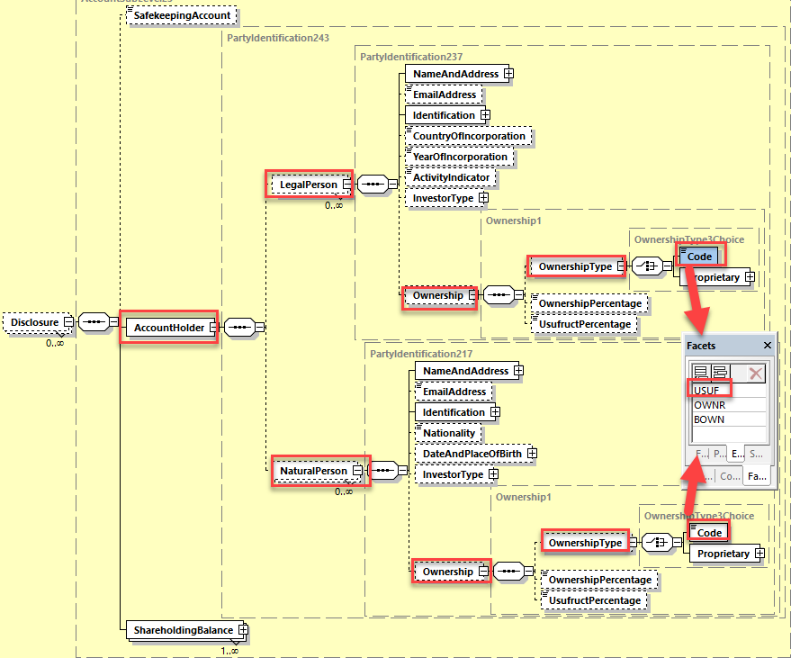

- Proposed timing:
The submitting organization confirms that it can implement the requested changes in the requested timing

Timing | - As requested

- Final decision of the SEG(s):

Approve | X
Comments:

Reject
Reason for rejection:

CR 1287 Add new Format for Activities Classification
- Origin of the request:
A.1 Submitter: FR NMPG
A.2 Contact persons: Jean-Paul Lambotte jean-paul.lambotte@euroclear.com,
Stéphane Péard stephane.peard@sgss.socgen.com),
Mihaela Fallourd mihaela.fallourd@bnpparibas.com
A.3 Sponsors: FR NMPG, FPM, ANSA, Euroclear France
- Related messages:
Seev.047.001.02 - Shareholders Identification Disclosure Response

- Description of the change request:
For the field: ActivityIndicator <ActvtyInd> <ActvtyInd> followed by ISIC format
[A-U]{1,1}[0-9]{0,4},
as of today: ISIC only available.
new format to be added: APE* to the current ISIC format and not authorized by the format restrictions as of today
*APE (“Activité principale exercée”) code -also called NAF (“Nomenclature d’Activité Française”)- and currently not authorized by the format restrictions.

- Purpose of the change:
This APE code has been defined by INSEE and was used in the scope of the former French Identification Process (TPI). Its presence is necessary for any Asset Manager issuing French funds. This data is already stored in the data system of each intermediary.

- Urgency of the request:
SR2024

- Business examples:
Examples illustrating the change request:

<ActvtyInd>
<ISIC>A1234</ ISIC >
<ActvtyInd>

<ActvtyInd>
<APE>7022Z</ APE >
<ActvtyInd>
Format 0-9]{0,4}[A-U]{1,1}

SEG/TSG recommendation:
This section is not to be taken care of by the submitter of the change request. It will be completed in due time by the SEG(s) in charge of the related ISO 20022 messages or the TSG for changes related to the BAH.

Consider |  | X | Timing
 |  |  | - Next yearly cycle: 2023/2024  (the change will be considered for implementation in the yearly maintenance cycle which starts in 2022 and completes with the publication of new message versions in the spring of 2023) |  | X
- At the occasion of the next maintenance of the messages
(the change will be considered for implementation, but does not justify maintenance of the messages in its own right – will be pending until more critical change requests are received for the messages)
- Urgent unscheduled
(the change justifies an urgent implementation outside of the normal yearly cycle)
 |  |  | - Other timing:
Comments:
At the June 2023 ET call, the ET did not agree with the proposal to add an activity indicator which is only locally valid in FR whilst an international activity indicator standards exists. We might have request for many other locally defined activity indicator otherwise and that would not be desirable.
However, since the CR submitter could not attend the ET call at the end of June to validate the business case, the CR could not be fairly defended. The CR will be rediscussed at the next ET call on August 31, 2023.

Reject
Reason for rejection:

- Impact analysis:
This change request impacts only the following messages:
seev.047.001.02 – ShareholderIdentificationDisclosureResponseV02

- Proposed implementation:
In the seev.047.001.02 (SIRE – ShareholderIdentificationDisclosureResponse) in sequence DisclosureInformarion / SafekeepingAccountAndHoldings / AccountSubLevel / Disclosure / AccountHolder / LegalPerson, replace the ISICIdentifier data type of the ActivityIndicator element by a choice between a code typed by ISICIdentifier and a ProprietaryIdentification element as illustrated below:

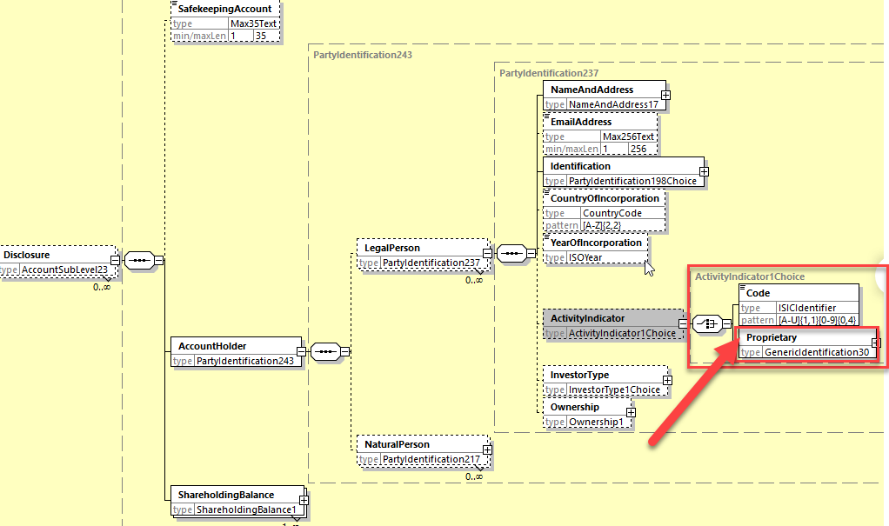

This solution is an alternative to the initial proposal from the submitter.

- Proposed timing:
The submitting organization confirms that it can implement the requested changes in the requested timing

Timing | - As requested

- Final decision of the SEG(s):

Approve | X
Comments:

Reject
Reason for rejection:

CR 1314 Add new ShareholdingType code for Legally Non Disclosable Type
- Origin of the request:
A.1 Submitter: Euroclear Sweden
A.2 Contact person: Åsa Lewenhagen, asa.lewenhagen@euroclear.com,.
A.3 Sponsors: SE NMPG
- Related messages:
seev.047.001.02 – ShareholderIdentificationDisclosureResponseV02
- Description of the change request:
We request a change of the seev.047 message - any of the following changes:
- Make the ‘Shareholder type’ optional but no additional SRD II flag:
  - If the shareholder identification is SRDII related: the recipient of the seev.047 must check if the shareholder type is present. If not, the seev.047 should be rejected.
  - If the shareholder identification is not SRDII related : no additional validation (shareholder type is optional).

- Make the ‘Shareholder type’ optional and add additional SRD II flag together with validation rule (if SRDII flag in seev.047, shareholder type is mandatory):
  - If the shareholder identification is SRDII related: the recipient of the seev.047 must check if the SRDII flag is present (which implies the shareholder type is there because of the network validation rule). If not, the seev.047 should be rejected.
  - If the shareholder identification is not SRDII related : no additional validation (maybe reject if the client has put the SRDII flag as this would not make sense in this case?)

- Add a fifth code in the ‘Shareholder Type’. Example NDLR (Not Disclosed due to Legal Reasons) with the usage: This type should only be used when the response is sent for a request where the issuer is not legally entitled to receive information regarding the type of shareholding (e.g., Swedish nominee reporting).

- Purpose of the change:
The Swedish market has a wish to use the SRD II messages for the local legal requirement for CSD participants that are nominees, i.e. that are allowed to hold securities in CSD accounts on behalf of clients, to provide information on their clients’ holdings upon request of the issuer or CSD. As the local legal context does not allow CSD participants to provide other information than what is specified in the legislation, the element ‘Shareholder type’ cannot be reported to the CSD. This means that these messages are not possible to be utilised for this purpose.

- Urgency of the request:
SR2024

- Business examples:
None
- SEG/TSG recommendation:
This section is not to be taken care of by the submitter of the change request. It will be completed in due time by the SEG(s) in charge of the related ISO 20022 messages or the TSG for changes related to the BAH.

Consider |  |  | Timing
 |  |  | - Next yearly cycle: 2023/2024  (the change will be considered for implementation in the yearly maintenance cycle which starts in 2022 and completes with the publication of new message versions in the spring of 2023) |  | X
- At the occasion of the next maintenance of the messages
(the change will be considered for implementation, but does not justify maintenance of the messages in its own right – will be pending until more critical change requests are received for the messages)
- Urgent unscheduled
(the change justifies an urgent implementation outside of the normal yearly cycle)
 |  |  | - Other timing:
Comments:

Reject | X
Reason for rejection:
The ET has reviewed the 4 solution options proposed below (the first 3 being solution design option proposed by SE NMPG):
1. Make ShareholdingType Optional: Cons raised by ET members: the possible absence of the element for SRDII request (which is mandatory for SRDII) will be problematic to handle for the response receiver and SRDII traffic volume is preeminent today.
2. Make ShareholdingType Optional and add an SRDII flag: Cons raised by ET members: See above + the presence of an SRDII indicator in responses might be confusing. This is the less favored solution amongst the 3 proposed.
3. Create additional ShareholdingType code "NDLR": Cons raise by ET members: This code being non SRDII compliant, this could also be detrimental to the STP processing of the response message if the code is used for SRDII requests.
4. Do nothing i.e. reject the CR as proposed by some ET members: The workaround could be that the response messages in the context of SE requests could still include the code "Unknown" if the shareholding type must not de disclosed.
The ET resolves to get a consensus on the following choices: a) Support solution 1 above or b) do nothing (solution 4 i.e. reject the CR).
A majority of the countries/Institutions present are in favour of rejecting the CR (i.e. 5 in favour, 3 in favour of solution 1 and 2 abstentions).
The CR is therefore rejected by the ET.

- Impact analysis:
This change request impacts only the following messages:
seev.047.001.02 – ShareholderIdentificationDisclosureResponseV02

- Proposed implementation:
The third option proposed (adding a code value to ShareholderType) for the implementation of this change is the cleanest solution as it includes a validation of the contents by schema and it avoids the usage of a complex validation rule in the message (option 2) whilst option 1 escape any validation and makes the handling of the message more complex for the recipient when this business case occurs.
In the seev.047.001.02 (SIRE – ShareholderIdentificationDisclosureResponse) in sequence DisclosureInformation / SafekeepingAccountAndHoldings / AccountSubLevel / Disclosure / ShareholdingBalance, add the new code value “Not Disclosed due to Legal Reasons” (NDLR) in the data type “ShareholdingType1Code” of the ShareholdingType element as illustrated below and with the following definition:
NDLR – Non Disclosed due to Legal Reasons: “The type of shareholding cannot be legally disclosed.
Usage: This type should only be used when the response is sent for a request where the issuer is not legally entitled to receive information regarding the type of shareholding (eg., Swedish nominee reporting).”

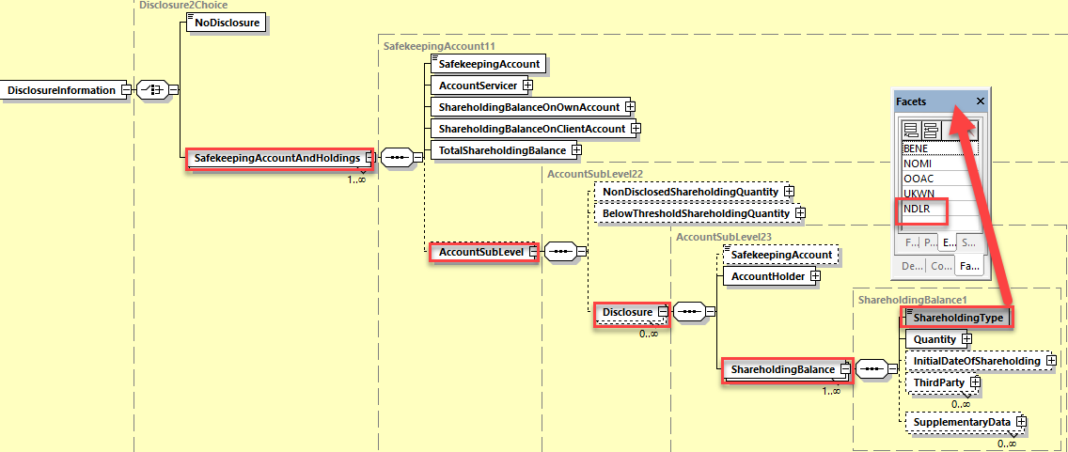

- Proposed timing:
The submitting organization confirms that it can implement the requested changes in the requested timing

Timing | - As requested

- Final decision of the SEG(s):

Approve
Comments:

Reject | X
Reason for rejection:
The ET has reviewed the 4 solution options proposed below (the first 3 being solution design options proposed by SE the NMPG):
1. Make ShareholdingType Optional: Cons raised by ET members: the possible absence of the element for SRDII request (which is mandatory for SRDII) will be problematic to handle for the response receiver and SRDII traffic volume is preeminent today.
2. Make ShareholdingType Optional and add an SRDII flag: Cons raised by ET members: See above + the presence of an SRDII indicator in responses might be confusing. This is the less favored solution amongst the 3 proposed.
3. Create additional ShareholdingType code "NDLR": Cons raise by ET members: This code being non SRDII compliant, this could also be detrimental to the STP processing of the response message if the code is used for SRDII requests.
4. Do nothing i.e. reject the CR as proposed by some ET members: The workaround could be that the response messages in the context of SE requests could still include the code "Unknown" if the shareholding type must not de disclosed and have a local market practice accordingly.
The ET resolved to get a consensus on the following choices:
a) Support solution 1 above or
b) do nothing (solution 4 i.e. reject the CR).
A majority of the countries/Institutions present are in favour of rejecting the CR i.e. 3 in favour of choice a) and 5 in favour of option b) and 2 abstentions.

