Change Request
for the update of an External Code Set
Note: this document is to be completed by parties that request to either add new codes or clarify the definition of existing codes or replace existing codes by new one(s) or expire existing codes in one of the External Code Sets used in ISO 20022 messages. All change requests conforming to this template that are received prior to the end of a quarter (31 March, 30 June, 30 September, 31 December) will be evaluated by the SEG and, if approved, incorporated in the following quarterly publication cycle of the External Code Sets (respectively, by end of May, August, November and February), unless otherwise specified by the SEG.

Origin of the request:

A.1 Submitter:

Name of the company, organization, group, initiative or community that submits the change request. | SIX Interbank Clearing Ltd.

A.2 Contact person:
Person that can be contacted for additional information on the request

A.2.1. First name, Last name | Roman Locher
A.2.2. Email address | roman.locher@six-group.com
A.2.3. Telephone | +41 58 399 41 25

A.3 Sponsors:
If the submitter acts on behalf of or has gained support from other organisations, groups, initiatives or communities, these should be listed as sponsors.

SIX Interbank Clearing is involved in several committees focused on questions of standardization concerning the national and international payment traffic. In this role SIX Interbank Clearing acts as a representative of the Swiss financial industry. SIX Interbank Clearing also operates the Swiss RTGS systems SIC for Swiss Francs (monitored and steered by the Swiss National Bank) and euroSIC in Euro.

Description of the change request:
Specify the request type: creation of new code set, update of existing code set, deletion of existing code set.
For the creation of a new code set or for updating an existing code set, also complete the table in section H below. For the addition of new codes, all the details must be specified, including a proposed code, a proposed code name, a clear definition, and any other indications, such as an example or format to be published with the code set.

Request type: creation, update, deletion | Update

Related External Code Set:
For updating or deleting an existing code set, indicate the exact name of the code set as indicated in the External Code Sets documents on iso20022.org. For creating a new code set, indicate a proposed name for the new code set.
A specific change request form must be completed for each code set to be updated.

ExternalSystemPartyType1Code
Addition of 4 new code values:
SYMG (System Manager)
SYOP (System Operator)
STPU (Standard Participant, unrestricted)
STPR (Standard Participant, restricted)

Notes:
- Scope of this CR is for the messages reda.015 (PartyQuery) and reda.017 (PartyReport). According to External Code Sets, "ExternalSystemPartyType1Code" is currently also used in messages reda.014 (PartyCreationRequest), reda.019 (SecuritiesAccountQuery), reda.021 (SecuritiesAccountReport), reda.041 (PartyActivityAdvice) and reda.043 (PartyAuditTrailReport).
- According to bilateral information from ISO 20022 RA these messages are under responsibility of the Securities SEG as SEG lead with the Payments SEG as secondary.

Purpose of the change:
Background, business context, community of users interested by the change and expected benefits/savings.
This section must explain why the existing code set needs to be changed. The reason for the update may be a business reason (e.g., evolution of market practice, or creation of new financial instruments), a technical reason (e.g., automation of the business process, or switch from a batch to a real time process), a regulatory reason (introduction, generally mandatory, of new rule/law) or the extension of the user community (newly identified business requirements).
In the payment infrastructures operated by SIX for RTGS (SIC / euroSIC) and upcoming Instant Payment service (SIC IP), the messages reda.015/reda.017 will be used to query information about all participating institutions connected to these services. In order to be able to map the different types of participants in these Swiss infrastructures, an unambiguous labeling is necessary. This shall be done by using official code values from "ExternalSystemPartyType1Code" code list. Since this code list currently does not contain any values, SIX Interbank Clearing Ltd is requesting 4 new code values to reflect its participant construct of aforementioned infrastructures.

Urgency of the request:
By default, valid change requests, subsequently approved by the SEG will be included in the following quarterly publication of External Code Sets, unless decided otherwise by the SEG.
If there is a need to have the new version of the related code set published earlier, the reason for the urgency and the expected consequences of a delay should be described here. Acceptance of such an unscheduled publication is subject to approval by the SEG.
Next quarterly publication of External Code Sets

Business examples:
Provide examples illustrating usage of the code set and indicate messages where the code set may be used.
Extract from message definition reda.015/017, Type <Tp> (SystemPartyType1Choice):
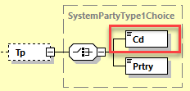
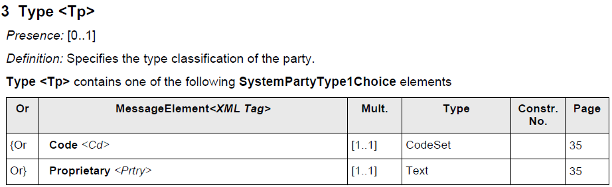

SEG recommendation:
This section will be completed by the SEG in charge of the related External Code Set.

Accept |  | X | Timing
 |  |  | Next possible quarterly release |  | X
 |  |  | Urgent request

Comments:

Reject

Reason for rejection:

DESCRIPTION OF THE CHANGE REQUEST

Type | Code Value | Code Name | Code Definition | Replaced By | Additional Information
Addition | SYMG | SystemManager | Party that defines the eligibility criteria of the system and is responsible for monitoring, controlling and, if necessary, operating the system. All authorizations are available to the system manager when interacting with the system.
Addition | SYOP | SystemOperator | Party that operates the system on behalf of the system manager (if different from the system manager) and is provided with specific authorizations by the system manager for this purpose.
Addition | STPU | StandardParticipant  Unrestricted | Party that owns an account in the system and can interact with the system or counterparties using all use cases available to standard participants.
Addition | STPR | StandardParticipant  Restricted | Party that owns an account in the system, but only supports a limited range of available use cases in interaction with counterparties.

