Change Request
for the update of ISO 20022 financial repository items
- Origin of the request:
A.1 Submitter: Swift
A.2 Contact person: evelyne.piron@swift.com; neil.buchan@swift.com
A.3 Sponsors: CBPR plus working group
- Related messages:
Pacs.009.001.10 - Financial Institution Credit Transfer
- Description of the change request:
The Financial Institution Credit Transfer requires a block “Underlying Financial Institution Credit Transfer” like the existing “Underlying Customer Credit Transfer”. Such additional data component is required when the pacs.009 is used as a cover of a previously sent direct pacs.009 with settlement method COVE.

- Purpose of the change:
In CBPR plus today, there is a scenario where a Debtor Agent sends a direct pacs.009 to the Creditor Agent, to announce the receipt of funds. This process is used in some markets to provide adequate notification to the Creditor Agent that funds are being sent through the respective intermediary agents, enabling that bank to position the expected incoming funds with their treasury so that the funds can be applied with good value to the beneficiary institution.
In such scenario, the settlement should be done using a covering pacs.009 to provide all information present in the direct pacs.009, but it is not possible since the current “Underlying Customer Credit transfer” component relates to a pacs.008.
The current workaround proposed by CBPR plus is to send a pacs.009 without an underlying component, and the underlying creditor (present in the direct pacs.009) must be populated in the element “Instruction for Creditor Agent with code /UDLC/) in the pacs.009 settlement message.
The below message flows (extract from the CBPR plus UHB) provides clarify on the scenario described:

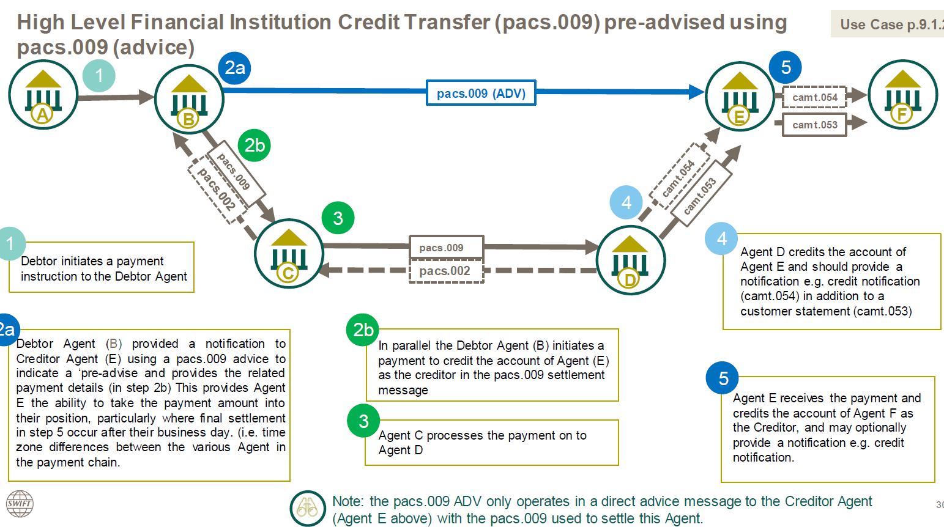

It is therefore requested to add the appropriate component in the pacs.009 to provide full party transparency in such scenario.

- Urgency of the request:
Next maintenance cycle
- Business examples:
N/A

SEG/TSG recommendation:
This section is not to be taken care of by the submitter of the change request. It will be completed in due time by the SEG(s) in charge of the related ISO 20022 messages or the TSG for changes related to the BAH.

Consider |  |  | Timing
 |  |  | - Next yearly cycle: 2024/2025  (the change will be considered for implementation in the yearly maintenance cycle which starts in 2023 and completes with the publication of new message versions in the spring of 2024) |  | X
- At the occasion of the next maintenance of the messages
(the change will be considered for implementation, but does not justify maintenance of the messages in its own right – will be pending until more critical change requests are received for the messages)
- Urgent unscheduled
(the change justifies an urgent implementation outside of the normal yearly cycle)
 |  |  | - Other timing:
Comments:

Reject
Reason for rejection:

