Change Request
for the update of an External Code Set
Note: this document is to be completed by parties that request to either add new codes or clarify the definition of existing codes or replace existing codes by new one(s) or expire existing codes in one of the External Code Sets used in ISO 20022 messages. All change requests conforming to this template that are received prior to the end of a quarter (31 March, 30 June, 30 September, 31 December) will be evaluated by the SEG and, if approved, incorporated in the following quarterly publication cycle of the External Code Sets (respectively, by end of May, August, November and February), unless otherwise specified by the SEG.

Origin of the request:

A.1 Submitter:

Name of the company, organization, group, initiative or community that submits the change request. | EPC – European Payments Council

A.2 Contact person:
Person that can be contacted for additional information on the request

A.2.1. First name, Last name | Christophe Godefroi
A.2.2. Email address | Christophe.godefroi@epc-cep.eu
A.2.3. Telephone | + 32 2 739 16 93

A.3 Sponsors:
If the submitter acts on behalf of or has gained support from other organisations, groups, initiatives or communities, these should be listed as sponsors.

The payment service providers (PSPs) community of SEPA (Single Euro Payments Area)

Description of the change request:
Specify the request type: creation of new code set, update of existing code set, deletion of existing code set.
For the creation of a new code set or for updating an existing code set, also complete the table in section H below. For the addition of new codes, all the details must be specified, including a proposed code, a proposed code name, a clear definition, and any other indications, such as an example or format to be published with the code set.

Request type: creation, update, deletion | update

Related External Code Set:
For updating or deleting an existing code set, indicate the exact name of the code set as indicated in the External Code Sets documents on iso20022.org. For creating a new code set, indicate a proposed name for the new code set.
A specific change request form must be completed for each code set to be updated.

ExternalServiceLevel1Code

Purpose of the change:
Background, business context, community of users interested by the change and expected benefits/savings.
This section must explain why the existing code set needs to be changed. The reason for the update may be a business reason (e.g., evolution of market practice, or creation of new financial instruments), a technical reason (e.g., automation of the business process, or switch from a batch to a real time process), a regulatory reason (introduction, generally mandatory, of new rule/law) or the extension of the user community (newly identified business requirements).

The EPC has recently created a new scheme, which is called the “One-Leg Out Instant Credit Transfer Scheme”. This scheme consists of a set of rules, practices and standards to achieve interoperability for the provision and operation of the Euro leg of an international instant payment instrument agreed at inter-PSP Level to support One-Leg Out (OLO) Instant Credit Transfer (OCT Inst) Transactions.
The characterization of this OCT Inst Scheme is to be achieved via the combination of
Service Level Code “EOLO” with the already broadly established Local Instrument Code
“INST”.

Urgency of the request:
By default, valid change requests, subsequently approved by the SEG will be included in the following quarterly publication of External Code Sets, unless decided otherwise by the SEG.
If there is a need to have the new version of the related code set published earlier, the reason for the urgency and the expected consequences of a delay should be described here. Acceptance of such an unscheduled publication is subject to approval by the SEG.

Publication in the next quarterly External Code Set is required given that this code will need to be included in version 1.0 of the OCT Inst implementation guidelines which are scheduled to be published by end of June 2023.

Business examples:
Provide examples illustrating usage of the code set and indicate messages where the code set may be used.

For example a pain.001 or pacs.008 message is sent to the next party in the chain with Service Level Code “EOLO”, in combination with Local Instrument Code “INST”, to indicate that the payment must be executed following the OCT Inst scheme. The OCT Inst scheme supports both incoming and outgoing OCT Inst Transactions (please see below diagrams) from the perspective of a payee/creditor and a payer/debtor respectively holding a payment account held at a Euro Leg-Based Payee’s PSP and at a Euro Leg-Based Payer’s PSP, and any related Exception Handling and Inquiries.
Incoming OCT Inst Transactions
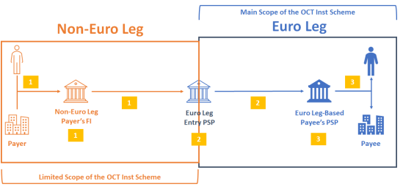
Outgoing OCT Inst Transactions
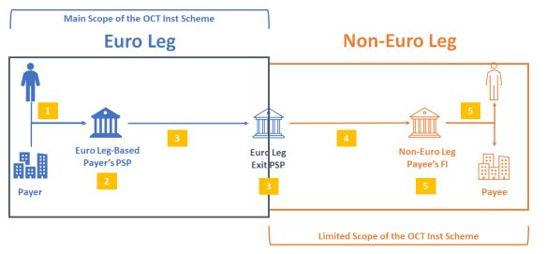

SEG recommendation:
This section will be completed by the SEG in charge of the related External Code Set.

Accept |  | X | Timing
 |  |  | Next possible quarterly release |  | X
 |  |  | Urgent request

Comments:

Reject

Reason for rejection:

DESCRIPTION OF THE CHANGE REQUEST

Type | Code Value | Code Name | Code Definition | Replaced By | Additional Information
Addition | EOLO | Euro One-Leg Out | Payment is executed following a Euro One-Leg Out Scheme

