Change Request
for the update of an External Code Set
Note: this document is to be completed by parties that request to either add new codes or clarify the definition of existing codes or replace existing codes by new one(s) or expire existing codes in one of the External Code Sets used in ISO 20022 messages. All change requests conforming to this template that are received prior to the end of a quarter (31 March, 30 June, 30 September, 31 December) will be evaluated by the SEG and, if approved, incorporated in the following quarterly publication cycle of the External Code Sets (respectively, by end of May, August, November and February), unless otherwise specified by the SEG.

Origin of the request:

A.1 Submitter:

Name of the company, organization, group, initiative or community that submits the change request. | J.P. Morgan Chase Bank

A.2 Contact person:
Person that can be contacted for additional information on the request

A.2.1. First name, Last name | Michael Pawlisz
A.2.2. Email address | Mike.pawlisz@jpmchase.com
A.2.3. Telephone | 1-813-495-4975

A.3 Sponsors:
If the submitter acts on behalf of or has gained support from other organisations, groups, initiatives or communities, these should be listed as sponsors.

Description of the change request:
Specify the request type: creation of new code set, update of existing code set, deletion of existing code set.
For the creation of a new code set or for updating an existing code set, also complete the table in section H below. For the addition of new codes, all the details must be specified, including a proposed code, a proposed code name, a clear definition, and any other indications, such as an example or format to be published with the code set.

Request type: creation, update, deletion | update

Related External Code Set:
For updating or deleting an existing code set, indicate the exact name of the code set as indicated in the External Code Sets documents on iso20022.org. For creating a new code set, indicate a proposed name for the new code set.
A specific change request form must be completed for each code set to be updated.

ExternalPaymentTransactionStatus1Code

Purpose of the change:
Background, business context, community of users interested by the change and expected benefits/savings.
This section must explain why the existing code set needs to be changed. The reason for the update may be a business reason (e.g., evolution of market practice, or creation of new financial instruments), a technical reason (e.g., automation of the business process, or switch from a batch to a real time process), a regulatory reason (introduction, generally mandatory, of new rule/law) or the extension of the user community (newly identified business requirements).

Background:

When the pain.002.001.03 payment status report was originally designed back in 2005, the original thinking was that this message would provide a status at both file and transaction level covering the workflow until the originating bank had sent the required payment instruction through to the clearing system. After this point, the tracking and monitoring workflow would be through any local clearing reports ultimately through the intraday and end of day bank statement. However, usage and market practice has changed this original thinking as the payment status message is now additionally used to report on the local clearing status in addition to the receipt by the beneficiary bank. It is this change in market practice that has highlighted an urgent need for an additional status reason code to be added to the existing external code list.

The Current Design:

The workflow diagram below highlights the accepted transaction level status reason codes that are currently available back to the corporate originator of the payment message through the payment status message (pain.002.001.03).

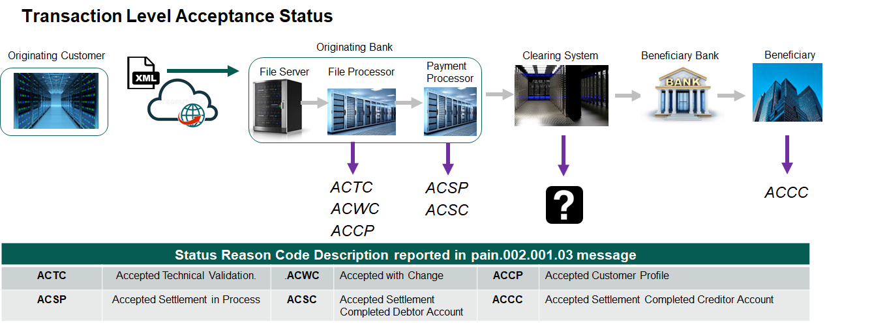

From the above, it is clear that tracking and monitoring through the originating bank submitting the payment instruction to the clearing system and tracking that the beneficiary account has been credited is not fully covered. The gap we have identified that applies to the US Fedwire transactions is around the clearing system process. In the US, banks have the ability to capture and include the allocated unique Fedwire transaction ID, which effectively confirms acceptance by the clearing that the transaction will be passed to the beneficiary bank. As this effectively represents a processing point after the originating bank has sent the payment to clearing, a new status reason code is required to provide full visibility on where this transaction is in the end-to-end workflow.

Business Request:

This request is for a new status reason code, which will enable the complete tracking of a transaction throughout the end-to-end workflow based on the pain.002.001.03 payment status report which is received by the originating corporate client. Introducing a new status reason code ACPD (accepted clearing processed), will facilitate this complete transaction level checking. Without this additional code, there is a gap in terms of originating banking partner providing a full and accurate tracking of the transaction.

Why is this Important:

With the growing focus on real-time within the broader industry, the business requirement to provide accurate monitoring and tracking of transactions is important. A specific use case in the USA relates to the real time payment of Taxes via wire payments. Given the penalties that can be applied for late payment of taxes, it is logical that companies want early visibility that a significant tax payment has been processed by the originating bank and passed through clearing to the beneficiary bank. Where an originating uses the same status reason code for multiple workflow tracking points, many systems today work purely on receiving a unique status reason code for each workflow tracking point - or the monitoring tool effectively reports the incorrect status - in this case a duplicate.

This additional code provides the opportunity for full and accurate status tracking, providing full visibility to the originating customer and the opportunity to act with more timely payment status information.

Urgency of the request:
By default, valid change requests, subsequently approved by the SEG will be included in the following quarterly publication of External Code Sets, unless decided otherwise by the SEG.
If there is a need to have the new version of the related code set published earlier, the reason for the urgency and the expected consequences of a delay should be described here. Acceptance of such an unscheduled publication is subject to approval by the SEG.

Business examples:
Provide examples illustrating usage of the code set and indicate messages where the code set may be used.

SEG recommendation:
This section will be completed by the SEG in charge of the related External Code Set.

Accept |  | X | Timing
 |  |  | Next possible quarterly release |  | X
 |  |  | Urgent request

Comments: Approved by Payments SEG on May 9th, 2022.

Reject

Reason for rejection:

DESCRIPTION OF THE CHANGE REQUEST

Type | Code Value | Code Name | Code Definition | Replaced By | Additional Information
Update | ACPD | Accepted Clearing Processed | Status of transaction released from the Debtor Agent and accepted by the clearing.

