DRAFT: Change Request
for the update of an External Code Set used in ISO 20022

- Origin of the request:
A.1 Submitter: Swedish Bankers’ Association
A.2 Contact persons:
Rasmus Lundquist (rasmus.lundquist@seb.se)
Carsten I. Pedersen (carsten.pedersen@nordea.com)
Jesper Vesterlund (jesper.vesterlund@swedishbankers.se)
A.3 Sponsors: The Swedish Bankers’ Association (Svenska Bankfóreningen)
- Related External Code Set:
ExternalDocumentType1Code
- Description of the change request:
Request the following new code:

CodeName | Name | Definition
LOAN | Loan Agreement Number | Loan Agreement Number to identify a loan.

- Purpose of the change:
The purpose of this change is to support Loan Agreement Number as a part of Structured Remittance Information.
In Sweden we are going into a new clearing house, P27, with new payment types and with that we see a need to add One new document type code to identify a Loan with a Number and potentially a Related Date (NB and RltdDt are already a part of the ReferredDocumentInformation Component under Structured Remittance Information). The change in predominately focused around pain.001.001.0x / pacs.008.001.0x and the related Cash Management messages (Core Banking).
This code will lead to more structured and transparency way of identifying a loan.

- Urgency of the request:
Next quarterly update of the external code list is fine.

- Business examples (based on pain.001.001.09):

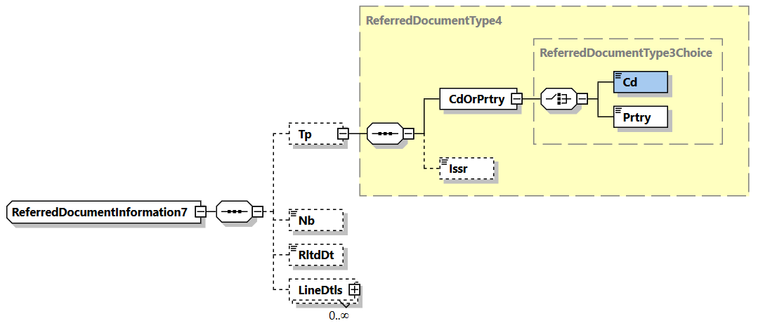

… XML Instance Fragment Start …
<Strd>
<RfrdDocInf>
<Tp>
<CdOrPrtry>
<Cd>LOAN</Cd>
</CdOrPrtry>
</Tp>
<Nb>333</Nb>
</RfrdDocInf>
</Strd>
… XML Instance Fragment End …

- SEG recommendation:
This section will be completed in due time by the SEG in charge of the related External Code Set.

Accept |  |  | Timing
 |  |  | - Next possible quarterly release
 |  |  | - Other timing:
Comments:

Reject
Reason for rejection:

